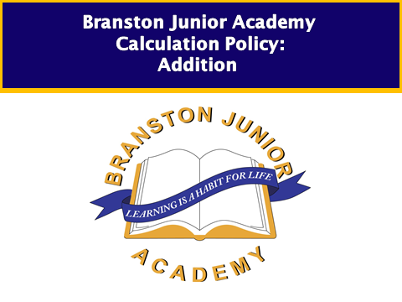
Children working at pre KS1 and year 1
Children are encouraged to develop a mental picture of the number system in their heads to use for calculation. They develop ways of recording calculations using pictures, etc.

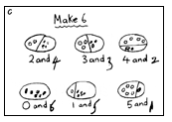

They use numberlines and practical resources to support calculation and teachers demonstrate the use of the numberline.

3 + 2 = 5
+1
+1

___________________________________________
0 1 2 3 4 5 6 7 8 9

Children then begin to use numbered lines to support their own calculations using a numbered line to count on in ones.

8 + 5 = 13
+1
+1
+1
+1
+1
0 1 2 3 4 5 6 7 8 9 10 11 12 13 14 15

Bead strings or bead bars can be used to illustrate addition including bridging through ten by counting on 2 then counting on 3.
Other concrete equipment may be used eg coins, cubes, everyday objects

Higher attaining pupils will also be able to solve calculations mentally such as:
- 20 + 18 = 20 + 10 + 8
= 30 + 8
= 38

10 + 20 = 30
- (12) + (23) = (35)
2 + 3 5

Children entering year 2
Children will begin to use ‘empty number lines’ themselves starting with the larger number and counting on.

- First counting on in tens and ones.

34 + 23 = 57
+1
+1
+1
+10
+10

34 44 54 55 56 57

- Then helping children to become more efficient by adding the units in one jump (by using the known fact 4 + 3 = 7).

34 + 23 = 57
+10
+10

+3

34 44 54 57

- Followed by adding the tens in one jump and the units in one jump.

34 + 23 = 57
+20
+3

34 54 57

- Bridging through ten can help children become more efficient.
37 + 15 = 52
+10
+2
+3

37 47 50 52

Children developing and securing year 2

- Count on from the largest number irrespective of the order of the calculation.

38 + 86 = 124
+30
+4
+4

86 116 120 124

- Compensation

49 + 73 = 122
+50

-1

73 122 123

Children will begin to use informal pencil and paper methods (jottings) to support, record and explain partial mental methods building on existing mental strategies.

Option 1 – Adding most significant digits first, then moving to adding least significant digits.

Moving to adding the least significant digits first in preparation for ‘carrying’.

- 267
+ 24 + 85
1 1 ( 7 + 4) 12 ( 7 + 5)
80 (60 + 20) 140 (60 + 80)
9 1 200
352

Higher attaining pupils will also be able to:
- Use partitioning to mentally add two two-digit numbers including crossing the tens boundary.
For example work out mentally and explain that 24 + 58 = 82 because it is 20 + 50 and 4 + 8 making 70 + 12 = 82

Children working at year 3

From this, children will begin to carry below the line.

625 783 367
+ 48 + 42 + 85
673 825 452
¹ ¹ ¹ ¹

Using similar methods, children will:
- add several numbers with different numbers of digits;
- begin to add two or more three-digit sums of money, with or without adjustment from the pence to the pounds;
- know that the decimal points should line up under each other, particularly when adding or subtracting mixed amounts, e.g. £3.59 + 78p.

Higher attaining pupils will be also be able to work out mentally that:

- 324 + 58 = 382 because it is 320 + 50 = 370 and 4 + 8 = 12, or 370 + 12 = 382

Children working at year 4
Most pupils will be able to work out mentally and explain that:

- 37 + 86 = 123 because it is 30 + 80 and 7 + 6 making 110 + 13 = 123
and
- 324 + 58 = 382 because it is 320 + 50 = 370 and 4 + 8 = 12 or 370 + 12 = 382

Children should extend the carrying method to numbers with at least four digits.

587 3587
+ 475 + 675
1062 4262
¹ ¹ ¹ ¹ ¹
Using similar methods, children will:
- add several numbers with different numbers of digits;
- begin to add two or more decimal fractions with up to three digits and the same number of decimal places;
- know that decimal points should line up under each other, particularly when adding or subtracting mixed amounts, e.g. 3.2 m – 280 cm.

Higher attaining pupils will also be able to use partitioning solve calculations such as 5.6 + 3. 7 = 5.6 + 3 + 0.7 mentally.

Children working at year 5
Most pupils will be able to work out mentally that 536 + 47 = 583 because it is 530 + 40 and 6 + 7 making 570 + 13 = 583 or use partitioning to mentally solve calculations such as 5.6 + 3. 7.

Children should extend the carrying method to number with any number of digits.

7648 6584 42
+ 1486 + 5848 6432
9134 12432 786
¹ ¹ ¹ ¹ ¹ ¹ 3
+ 4681 11944
¹ ² ¹

Using similar methods, children will
- add several numbers with different numbers of digits;
- begin to add two or more decimal fractions with up to four digits and either one or two decimal places;
- know that decimal points should line up under each other, particularly when adding or subtracting mixed amounts, e.g. 401.2 + 26.85 + 0.71.

Children working at year 6
Will work with decimals and mixed place values. Securing addition through problem solving and BODMAS.

