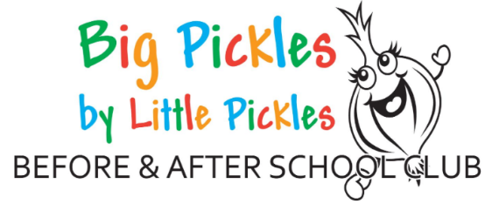

Welcome to Big Pickles Before and After School Club

Big Pickles Before and After School Club are committed to providing the best care for all children. We have two sites which run at Branston Infants School and Branston Junior Academy. We are a committee led organisation, which is made up of trustees who are a group of volunteers, some of whom are parents, past and present. Without our trustees our Before and After school club could not open.

Introduction to Big Pickles
We would like to welcome you and your child to Big Pickles Before and Afterschool Club. We are open for children who are in reception class to year 6.
We operate from 7.45 AM until the start of school in the morning. In the afternoon, we open from the end of school until 5.45PM - Monday to Thursday. On a Friday we close at 4.30PM.
The Infants site run an 8.30 AM drop off session every morning. You do not need to book a place to use the drop off service.

Fees
The following fees apply to Big Pickles Before and After school club.
Session | Fees | Additional Information
Before School Session | £5.50 | Includes Breakfast
Drop Off Session 8:30am onwards (INFANT SITE ONLY) | £2.50 | Payable in cash at the time of drop off
After School Session 4:30pm collection | £5.00 | Includes Snack
After School Session 5:45pm | £10.00 | Includes Snack on arrival plus additional fruit as required
Late Charge | £5.00

All invoices will be sent out prior to the start of the month and payment will need to be made by the date stated on the invoice. If fees are not received following an email reminder, then unfortunately your child will not be allowed to attend their session as normal until fees are paid in full. You will be notified that your child will not have a place at their normal session.
Sessions are to be booked in advance of the month start. You will be notified via text of the cut-off date for any changes or amendments you wish to make to your normal sessions. Normal sessions do not need booking each month and will instead be on a rolling agreement with yourself until we are notified otherwise.
Additional sessions may be added after the cut-off date but are subject to availability. Fees for extra sessions will be payable on production of an invoice which you will receive via email at the end of that month.
Parents who have booked and paid for sessions but decide to collect their child(ren) directly from school or early from after school club will not receive a refund as a place will have already been allocated.

Breakfast and Snack at Big Pickles
At Big Pickles we follow a healthy eating policy. Breakfast will be offered to children attending our morning session, a range of breakfast foods such as Cereals, Toast, Fruit and Yogurt are offered.
Afternoon Snack consists of a variety of healthy and light foods which will help tide your child over until they arrive home for their family meal. Fruit will be available throughout the session in addition to our main snack.
Drinks are supplied throughout all our sessions and include water or milk at breakfast. We provide squash at the afternoon session along with water or milk.
We ensure that all dietary requirements are met, we just ask you inform a pickles member of staff before your child starts. You are welcome to send in specialist snacks if your child has an allergy or intolerance. Please inform a staff member in such cases.

Activities
At Big Pickles we offer a wide range of resources and activities for children to take part in and follow children’s interests closely. We can use the outdoor areas within the school grounds and on the days where the weather is bad, we are able to use the school’s halls.

How to contact us
There are many ways you can contact us at Big Pickles.
For general queries or session changes please email- big-pickles@little-pickles.com
For anything urgent please phone- 01522 793112 – Please leave a message with the preschool if it is out of session times. They will ensure we receive your message.
Facebook - Big Pickles before and after school club.

