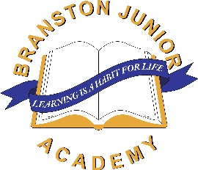

**Would you like to help your child with their learning?**

We are holding an informal ‘Parent Information’ session

at Branston Junior Academy on **Wednesday 1st November 2023**

from **3.45-4.45pm**.

This will be in our school hall.

Here you will find our teachers happy to talk to you about the following subjects:

* Miss Kisby Talking about helping your child with **reading**, including a really easy way

of reading called ‘**Echo Reading**’.

* Miss Perkins Talking about supporting your child with **Maths**.

* Mrs Simpson A chance to speak to her as SENDCO (Special Educational Needs

Coordinator) about general **SEND** (Special Educational Needs and Disabilities) provision. *(Please note, this will not be a time to discuss individual children).*

* Mrs James Talking about helping your child with practising their **times tables**.

* Miss Gethings Talking about how to help your child with learning their **spellings**.
* Mr Simpson Talking about how to help your child ‘**read for inference’** – eg; **reading**

**to gain understanding of the text**, as opposed to just reading the letters on the page.

* Miss Tysoe Talking about helping your child with their **writing**, and the way in which

we teach writing at BJA, called ‘**Talk for Writing**’.

* **Please come at any time between 3.45 and 4.45pm, to chat to the teachers about the above items – please come straight into the hall.**
* **Please note – teachers will not be talking about individual children, it is not a Parents Evening.**
* **Children are welcome to attend, however we ask that they remain with you as you chat to the various teachers.**