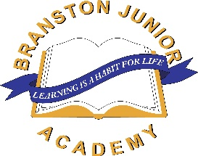

Station Road, Branston, Lincoln LN4 1LH – 01522 880555

Facsimile 01522 880556 – e-mail: enquiries@branstonjunioracademy.co.uk

**Re: Halloween Film Night**

6/10/23

Dear Parents/ Carers,

On **Thursday 19th October**, we will be hosting a Halloween film night after school. The cost of the event is £4- this will include a slice of pizza, a drink of squash and some popcorn (dietary requirements will be catered for.)

The film we will be showing is: The Addams Family Values (Rating; PG)

The showing will begin at **3:30pm** (immediately after school) and children will need to be collected at **5:30** from school by an adult from the playground (in the same manner as the end of the day)

**If your child wishes to join us for our film night, they will need to bring £4 (cash) and complete the permission slip below by Friday 13th October (no late replies will be accepted.)**

All profits made will go towards school fund.

Many thanks,

Miss Perkins

I give permission for my child ________________________________________

in class ________________________ to attend the film night at Branston Junior Academy.

I enclose £4 cash and I understand that my child needs to be collected from Branston Junior Academy at 5:30pm

Signed__________________________________________________