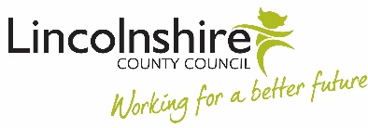
Wednesday 16th June
at Branston Junior Academy
Drop in for a cuppa and a biscuit
with us between 9.10am-10.30am.
Family Learning is all about learning together.
Join us to find out more about our free workshops and courses for families, that we deliver in your child's school
Meet Helen who can answer your questions about Family Learning and talk to us about what activities you would like to do with your child.
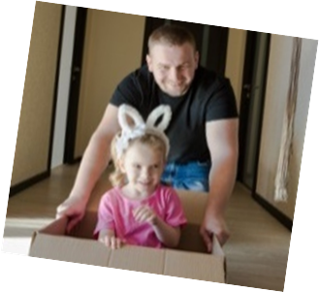
See Amanda Simpson or Rachael Shaw for more information
