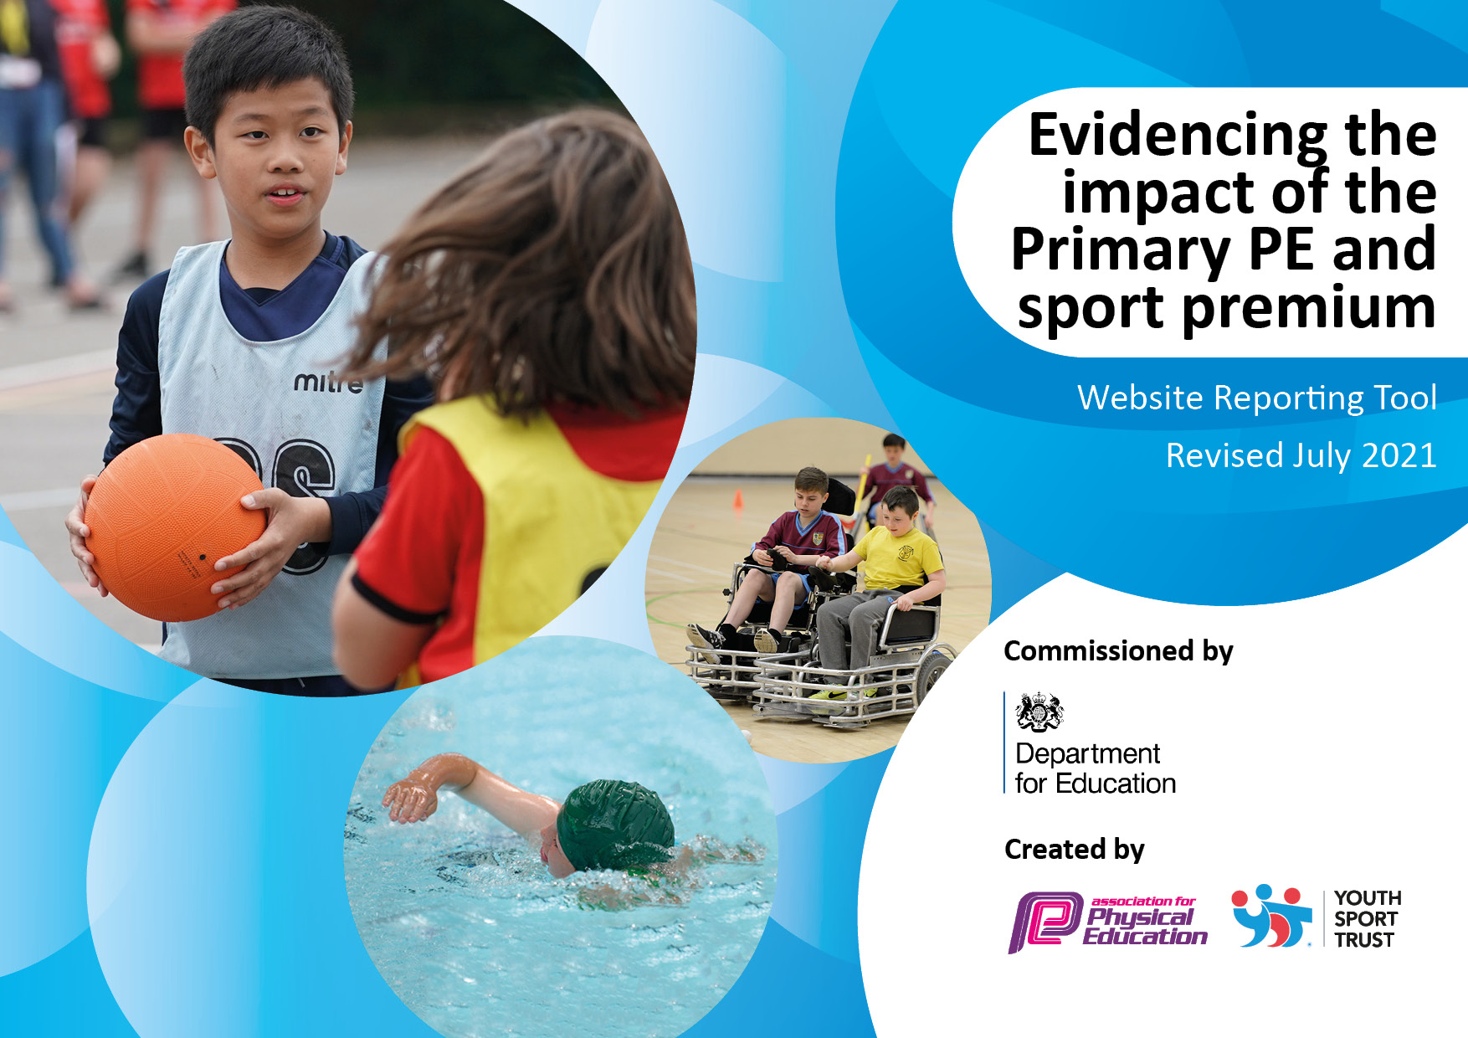
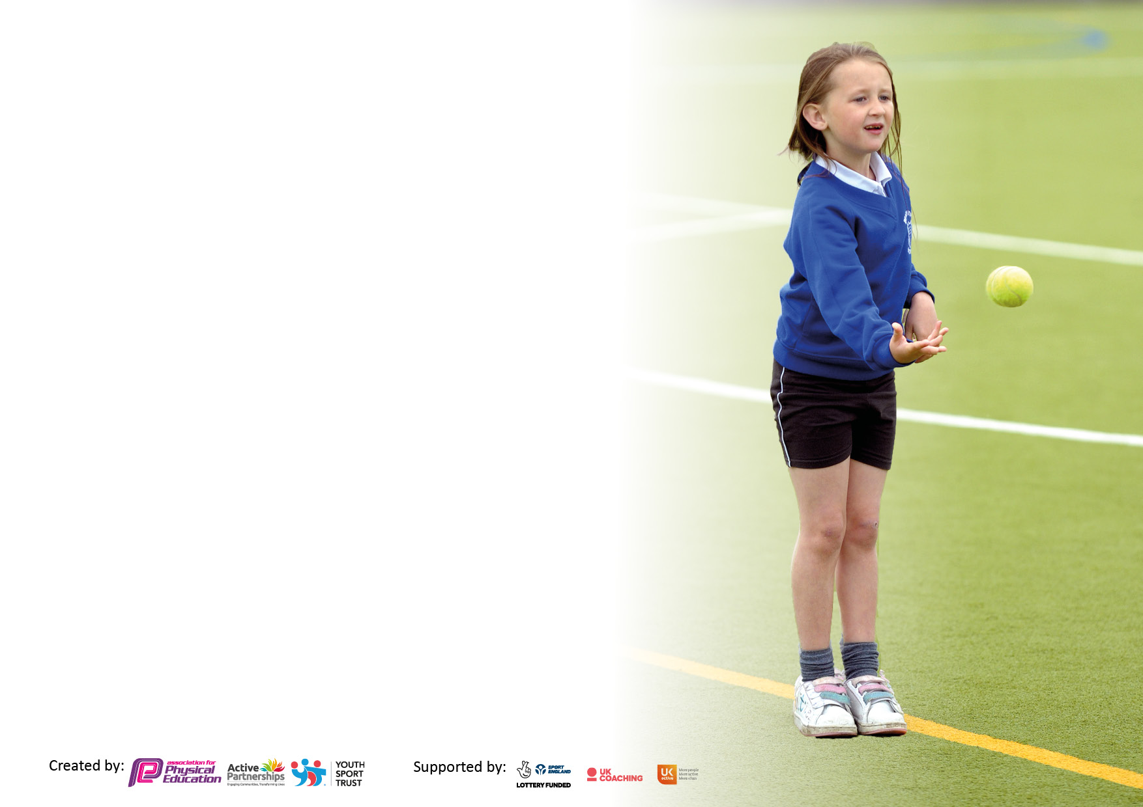

It is important that your grant is used effectively and based on school need. The Education Inspection Framework makes clear there will be a focus on ‘whether leaders and those responsible for governors all understand their respective roles and perform these in a way that enhances the effectiveness of the school’.

Under the Quality of Education Ofsted inspectors consider:
Intent - Curriculum design, coverage and appropriateness
Implementation - Curriculum delivery, Teaching (pedagogy) and Assessment
Impact - Attainment and progress

To assist schools with common transferable language this template has been developed to utilise the same three headings which should make your plans easily transferable between working documents.

Schools must use the funding to make additional and sustainable improvements to the quality of Physical Education, School Sport and Physical Activity (PESSPA) they offer. This means that you should use the Primary PE and sport premium to:

- Develop or add to the PESSPA activities that your school already offer
- Build capacity and capability within the school to ensure that improvements made now will benefit pupils joining the school in future years
- The Primary PE and sport premium should not be used to fund capital spend projects; the school’s budget should fund these.

Pleasevisitgov.ukfortherevisedDfEguidanceincludingthe5keyindicatorsacrosswhichschoolsshoulddemonstrate animprovement.Thisdocumentwillhelpyoutoreviewyourprovisionandtoreportyourspend.DfEencouragesschools to use this template as an effective way of meeting the reporting requirements of the Primary PE and sport premium.

We recommend you start by reflecting on the impact of current provision and reviewing the previous spend.

Schools are required to publish details of how they spend this funding, including any under-spend from 2019/2020, as well as on the impact it has on pupils’ PE and sport participation and attainment. All funding must be spent by 31st July 2022.

We recommend regularly updating the table and publishing it on your website throughout the year. This evidences your ongoing self-evaluation of how you are using the funding to secure maximum, sustainable impact. Final copy must be posted on your website by the end of the academic year and no later than the 31st July 2021. To see an example of how to complete the table please click HERE.
Created by: Supported by:

Details with regard to funding
Please complete the table below.
Swimming Data
Please report on your Swimming Data below.
Total amount allocated for 22/23: | £17,590
Total Spent: | £17,957
Swimming Data
Please report on your Swimming Data below.
Meeting national curriculum requirements for swimming and water safety.

N.B. Complete this section to your best ability. For example you might have practised safe self-rescue techniques on dry land which you can then transfer to the pool when school swimming restarts.
Due to exceptional circumstances priority should be given to ensuring that pupils can perform safe self rescue even if they do not fully meet the first two requirements of the NC programme of study
What percentage of your current Year 6 cohort swim competently, confidently and proficiently over a distance of at least 25 metres?  N.B. Even though your pupils may swim in another year please report on their attainment on leaving primary school at the end of the summer term 2020.  Please see note above | 76%%
What percentage of your current Year 6 cohort use a range of strokes effectively [for example, front crawl, backstroke and breaststroke]?  Please see note above | 76%%
What percentage of your current Year 6 cohort perform safe self-rescue in different water-based situations? | 76%%
Schools can choose to use the Primary PE and sport premium to provide additional provision for swimming but this must be for activity over and above the national curriculum requirements. Have you used it in this way? | Yes/No

Action Plan and Budget Tracking
Capture your intended annual spend against the 5 key indicators. Clarify the success criteria and evidence of impact that you intend to measure to evaluate for pupils today and for the future.

Academic Year: 2020/21 | Total fund allocated: | Date Updated:
Key indicator 1: The engagement of all pupils in regular physical activity – Chief Medical Officers guidelines recommend that primary school pupils undertake at least 30 minutes of physical activity a day in school
Intent | Implementation |  | Impact
Your school focus should be clear what you want the pupils to know and be able to do and about  what they need to learn and to  consolidate through practice: | Make sure your actions to achieve are linked to your intentions: | Funding allocated: | Evidence of impact: what do pupils now know and what can they now do? What has changed?: | Sustainability and suggested next steps:
P.E Equipment updated and restocked. | Take stock of the P.E equipment in P.E cupboard and compare stock with the P.E lessons for the year and order what is needed so that effective P.E lessons can happen (PE planned in 4 x a week) | £1023 | P.E equipment was stocked so that no child had to share equipment and all could be active within their P.E lessons. | Good quality equipment will have longevity. Enough equipment for all children to take part in physical activity.
Contribution to the hall floor. |  | £1497.50 |  | Good quality equipment will have longevity. Safe space to take part in physical activity.
Key indicator 2: The profile of PESSPA being raised across the school as a tool for whole school improvement
Intent | Implementation |  | Impact
Play Leader Training  Golden Mile | Make Play Leaders a Y6 ‘job’ children can apply for – training to be undertaken so the Y5 children can confidently apply for this job next year – this will focus on them supporting at break times for mainly the younger children to help socialise new children to the school.  Regardless of their relationship with physical activity, The Golden Mile is an inclusive way to promote healthy habits, improve wellbeing | £1200 | Children enjoyed the training and felt they were prepared to apply for the job ready for their role as Y6. | Need to role out their job in school and work with yr3/4 children.

Key indicator 3: Increased confidence, knowledge and skills of all staff in teaching PE and sport
Intent | Implementation |  | Impact
*IN THE LAST BUDGET A SCHEME FOR DANCE AND A 4 YEAR SUBSCRIPTION FOR A SCHEME WAS BOUGHT IN – THEREFORE WASN’T A HIGH PRIORITY FOR SPENDING – MORE SO FOCUS ON USING THESE SCHEMES. CPD TO BE PLANNED IN FOR 23/24 BUDGET* |  |  |  | Next Step: CPD for 3 staff members on the teaching of gymnastics – delivered by Premier Education.
Key indicator 4: Broader experience of a range of sports and activities offered to all pupils
Intent | Implementation |  | Impact
*INDICATOR FOCUS FOR THE YEAR*  Activity Week Premier Education sessions.  Climb Higher  Bounce Beyond  Red Panda  Extra resources  Boxercise License  MSP Clubs  Mr Gillespie Clubs | To focus lot of our budget on creating opportunities for all children to experience a wide range of sports that can be available to them during our directed ‘Activities Week’  Extra resources to be bought so that teachers can lead events and keep sustainable for some activities.  Keeping LP up-to-date so that Boxercise club can run throughout the year.  Budgeting for clubs to be ran after school and free opportunities for all children to be able to attend. | £400  £935  £400  £1710  £610  £43.50  £2695  £1685 | Activity week was a huge success and gave all children opportunity to access all events. Children could discuss the impact of the week and it is something as a school we feel was valuable to all children.  High attendance of all clubs shows impact of spenditure on clubs – we will always strive whilst we have money to make these opportunities free to all children and encourage participation in after school opportunities. Running Mon-Thurs every week. | Next Step:  Plan another activity week for 23/24.  Keep running various after school sports clubs open to all children.

Key indicator 5: Increased participation in competitive sport |  |  |  | Percentage of total allocation:
 |  |  |  | %
Intent | Implementation |  | Impact
Travel to events  Cover for staff to go to events  Sports day medals | Making access to events available to all students and taking a wide range of students to a variety of events spanning Lincoln. Cover so class teachers can attend these events too.  Giving an extra purpose to the events we hold in school. | £3171  £2556  £39.93 | We had a high percentage of children attend a variety of events and made this accessible to all. We paid for bigger travel to more children could attend and didn’t rely on parent participation.  Covering staff made it possible for all staff to have opportunity to attend these events so the support could be from a wider range of people. | Next Step:  Make this a key priority for next years budget as it gives all children an opportunity.  Make more of intra-school competition.

Signed off by
Head Teacher:
Date:
Subject Leader: | E.Tysoe
Date:
Governor:
Date:

