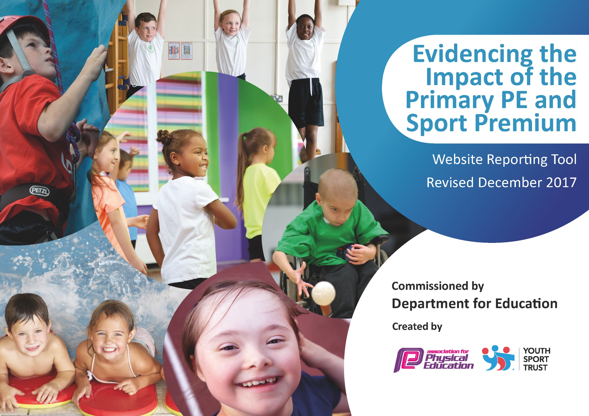
Schools must use the funding to make additional and sustainable improvements to the quality of PE and sport they offer. This means that you should use the Primary PE and Sport Premium to:

- develop or add to the PE and sport activities that your school already offers
- build capacity and capability within the school to ensure that improvements made now will benefit pupils joining the school in future years

Please visit gov.uk for the revised DfE guidance including the 5 key indicators across which schools should demonstrate an improvement. This document will help you to review your provision and to report your spend. DfE encourages schools to use this template as an effective way of meeting the reporting requirements of the Primary PE and Sport Premium.

We recommend you start by reflecting on the impact of current provision and reviewing the previous spend.
Under the Ofsted Schools Inspection Framework, inspectors will assess how effectively leaders use
the Primary PE and Sport Premium and measure its impact on outcomes for pupils, and how effectively governors hold them to account
for this.

Schools are required to publish details of how they spend this funding as well as on the impact it has on pupils’ PE
and sport participation and attainment.
We recommend regularly updating the table and
publishing it on your website as evidence
of your ongoing review into how you are using the money
to secure maximum, sustainable impact. To see an example of how to complete the table please click HERE.

Support for review and reflection - considering the 5 key indicators from DfE, what development needs are a priority for your setting and your students now and why? Use the space below to reflect on previous spend, identify current need and priorities for the future.
Key achievements to date: | Areas for further improvement and baseline evidence of need:
In relation to key indicator 1:  We continue to make time in the day for children, throughout the whole school, to complete ‘the daily mile’ which is helps both their mindset and their stamina.  We also continue to build up the equipment for break-times to keep the children as active as they can be during their time outside out of opportunity and choice.  In relation to key indicator 2:  We have invested in ‘Active Maths’ to try and implement PE into the teaching of maths to see if this raises engagement from certain pupils (unable to role out due to covid – trying again in 20/21)  In relation to key indicator 3:  We were able to support 2 teachers in their teaching of P.E by investing in training.  In relation to key indicator 4:  We have spent money on creating opportunities for most children to have a broader range of sports they experience – both in school and out of school  In relation to key indicator 5:  More children this year have had a chance to participate in competitive sport – taking a variety of children and being able to take more ‘C’ teams.  I feel all of these achievements feed through to key indicator 2. | Make sure that Active Maths is used throughout the term in the targeted maths sets.  Make sure the PE scheme is being used as it is intended.  Looking forward, we still need to put more training for teachers on how to effectively deliver their lessons – The feedback from the teachers that received it this year was very positive so more time and money needs to be invested in this.  Use money in a more sustainable way – MUGA’s have been researched and plan had to be put on hold but able to move funding forward to 20/21  Make more contact with surrounding schools on how to achieve GOLD Sport Mark and with surrounding sports clubs to promote sports both in and out school.  There were a lot of events/training/G&T specific/ambassador events that were planned for post March lockdown. We are looingk forward to how we can get back on track in any way depending on the future plans for PE and competitions in school – under spend premium due to this  (All Covid-dependent)

Meeting national curriculum requirements for swimming and water safety | Please complete all of the below*:
What percentage of your current Year 6 cohort swim competently, confidently and proficiently over a distance of at least 25 metres? | 84%
What percentage of your current Year 6 cohort use a range of strokes effectively [for example, front crawl, backstroke and breaststroke]? | 71.43%
Schools can choose to use the Primary PE and Sport Premium to provide additional provision for swimming but this must be for activity over and above the national curriculum requirements. Have you used it in this way? | Yes/No No

Academic Year: 2019/2020 | Total fund allocated: £17,590.00 | Date Updated: 31.08.2020
Key indicator 1: The engagement of all pupils in regular physical activity – Chief Medical Officer guidelines recommend that primary school children undertake at least 30 minutes of physical activity a day in school
School focus with clarity on intended impact on pupils: | Actions to achieve: | Funding allocated: | Evidence and impact: | Sustainability and suggested next steps:
Because of the impact we had last year on equipment in the playground, we decided to invest in more, to keep the children active at breaktimes; as a higher percentage of children choose to be active using the equipment provided at lunch time and break times. They see this as less directed time to be active but more children do choose active play. | More research into different types of play equipment that can be fun and active for the children during their 45-minute allocated outside time during break and lunch. | £670.40 | Another year where children, of all abilities have used the equipment as intended and they are 90% more active over playtimes – there is more play together too. The equipment has also filtered into lessons which make more use of circuit style lessons in PE thus making PE more active than before. | Interview children to see what they feel would make their play time more active – Is there anything we could purchase to help this?  To progress – ask staff, where else could we be more specific during a school day  (NB: Active Maths on 20/21 agenda)
Key indicator 2: The profile of PE and sport being raised across the school as a tool for whole school improvement
School focus with clarity on intended impact on pupils: | Actions to achieve: | Funding allocated: | Evidence and impact: | Sustainability and suggested next steps:
We have invested in ‘Active Maths’ to be used in targeted Maths classes.  Impact: Use of PE being used in the school day – not just in PE specific lessons. This will hopefully have a positive impact on both children’s attainment and engagement in both Maths and PE  Roll out a new job for Y6 to be ‘Play leaders’ for the academic year 19/20 – they will develop leadership skills and interact with different children and learn new skills whilst on the job too – also related to our whole school values, ‘relationship, respect, responsibility. – using equipment purchased through funding. | Engage with Active Maths company on how best to use this tool.  Research schools who may use this – on teacher forums  Make sure teachers feel confident using this tool – give time to explore. | £580.50 | No evidence of this being implemented in lessons due to covid and school closures.  Started in Feb 20 and was successful in the weeks they were able to carry it out in, before March Lockdown. | Begin to roll out Active Maths across the whole school and engage with teachers who are using it – evaluating the impact it is having on their teaching/children.  Interview children in specific maths classes to gauge interest and engagement.  Possible training from Active Maths or staff meetings.

Key indicator 3: Increased confidence, knowledge and skills of all staff in teaching PE and sport
School focus with clarity on intended  impact on pupils: | Actions to achieve: | Funding  allocated: | Evidence and impact: | Sustainability and suggested  next steps:
To work alongside PE specialists to deliver training to staff based on their PE lessons.  Impact: staff to feel more confident in their knowledge and confidence in teaching PE and upskilling themselves.  Continued provision of PE scheme to help teachers deliver a more skill-specific PE curriculum  Buying a dance-specific scheme that relates to our environment topic and will act as a guide to help teachers feel more confident in their delivery of something they before felt least confident in delivering. | Select staff to undertake training.  Work alongside MSP to allocate training that will cater to our needs. | £865.49 | 2 teachers worked with an MSP employee to learn new strategies to use in their teaching of PE. This was undertaken over a duration of weeks and built up from watching the specialist to being observed by the specialist  After interviewing the teachers, both gave positive feedback on their experience and they expressed that they felt confident in how to plan their PE lessons effectively as they had broadened their teaching skills. | Plan in more training for each term for a variety of teachers to undertake similar training.  Make sure PE observations are undertaken to ensure knowledge from training is being used and having an impact  Ensure scheme that was bought previously is being used – is there anything the staff feel is missing?  Select children to make sure equipment is kept in good condition and there to be used when needed.
Key indicator 4: Broader experience of a range of sports and activities offered to all pupils
School focus with clarity on intended  impact on pupils: | Actions to achieve: | Funding  allocated: | Evidence and impact: | Sustainability and suggested  next steps:
With the PE Premium we are able to offer a wider range of after school sports clubs so that children have a broader choice, leading to greater participation.  The training received by the chosen staff members focused on Lacrosse – which we had the equipment for but wasn’t being used  Working alongside SGO has enabled us to give opportunities for new sports that would have otherwise not been an option. | Work with MSP to choose after school clubs that would support promoting a broader experience for pupils  Employ a qualified Sports Coach (Jim Gillespie) to provide additional after-school clubs. | £2,342.00 | More children attending the variety of clubs offered in school.  Staff using the skills learnt in training to add a greater experience of different sports.  More varied groups of children attending inter-competitions that weren’t available to them before. | Train more staff in a variety of varied sports that we have the equipment for so that extra-curricular clubs can be led within the current staff.  Reach out to local sports clubs to work alongside the school to see how we could be a partnership for each other.
Key indicator 5: Increased participation in competitive sport
School focus with clarity on intended  impact on pupils: | Actions to achieve: | Funding  allocated: | Evidence and impact: | Sustainability and suggested  next steps:
We have had another year supported by our local SGO which has given children across all year groups with the opportunity to take part in a wide range of inter-school competitions and tournaments: (usually would have been more but due to covid-closures we didn’t attend all planned)  - Multi-Sports  - Football  - Girls Football  - Hockey  - Netball  - Athletics  - Boccia & Curling & Seated Volleyball  - Rugby  - Cricket  As some were skill-based competitions we were able to send a higher percentage of children to these tournaments which also saw increased participation in our intra-school tournaments.  To be able to participate in these tournaments the premium pays for cover and transport  Continued participation in the netball league means paying - netball league fees and making sure netball court is suitable. | Release teachers to attend tournaments  Provide transport to take away barrier of parent transport issues  Choose a wider range of children for tournaments to increase participation – not just based on ability  Promote competitive sport both in and out of school | £1,044.99 | Higher percentage of children attending events  2 ‘Inclusive’ teams getting through to the Sainsburys school games.  More children volunteering to take part in intra-school events. | Continue to enter and promote participation in inter-school sports competition.  Plan more ‘inclusive’ intra-school competitions throughout the year.  Make links with local schools to keep inter-school competitions in the future.  (All Covid dependent)

