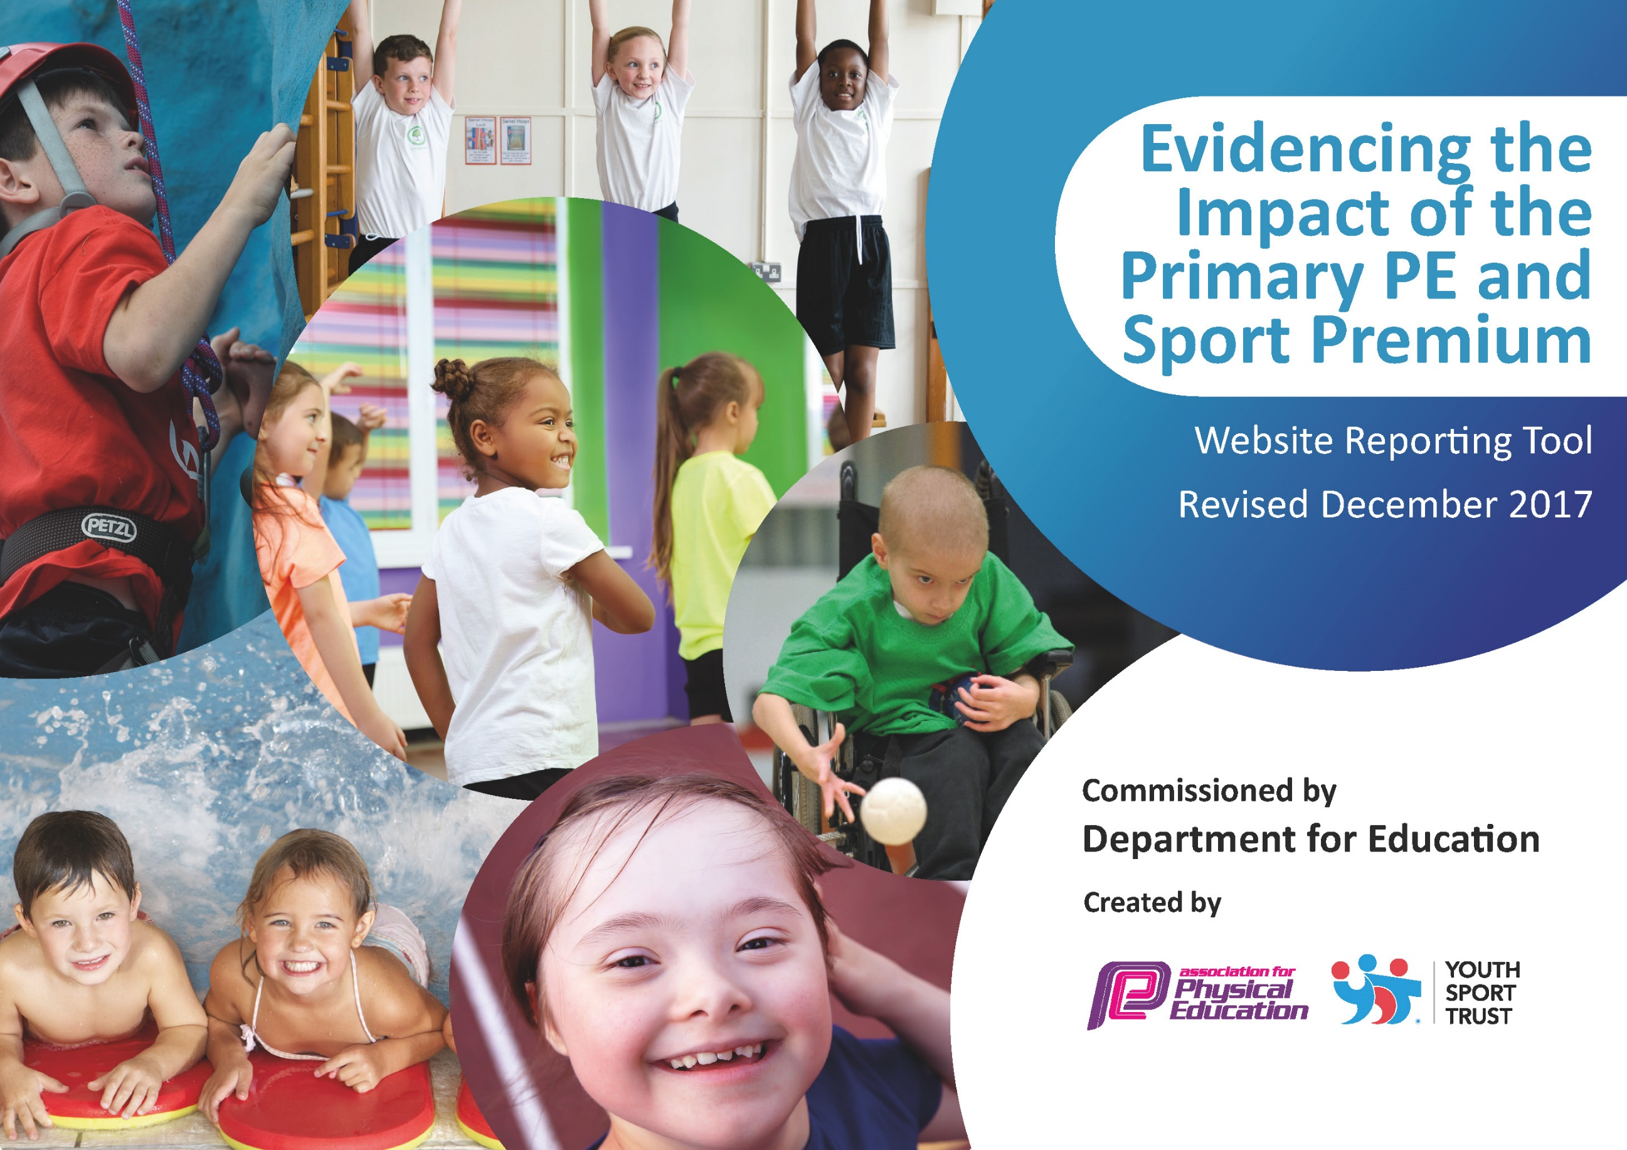
Schools must use the funding to make additional and sustainable improvements to the quality of PE and sport they offer. This means that you should use the Primary PE and Sport Premium to:

- develop or add to the PE and sport activities that your school already offers
- build capacity and capability within the school to ensure that improvements made now will benefit pupils joining the school in future years

Please visit gov.uk for the revised DfE guidance including the 5 key indicators across which schools should demonstrate an improvement. This document will help you to review your provision and to report your spend. DfE encourages schools to use this template as an effective way of meeting the reporting requirements of the Primary PE and Sport Premium.

We recommend you start by reflecting on the impact of current provision and reviewing the previous spend.
Under the Ofsted Schools Inspection Framework, inspectors will assess how effectively leaders use
the Primary PE and Sport Premium and measure its impact on outcomes for pupils, and how effectively governors hold them to account
for this.

Schools are required to publish details of how they spend this funding as well as on the impact it has on pupils’ PE
and sport participation and attainment.
We recommend regularly updating the table and
publishing it on your website as evidence
of your ongoing review into how you are using the money
to secure maximum, sustainable impact. To see an example of how to complete the table please click HERE.

Support for review and reflection - considering the 5 key indicators from DfE, what development needs are a priority for your setting and your students now and why? Use the space below to reflect on previous spend, identify current need and priorities for the future.
Key achievements to date: | Areas for further improvement and baseline evidence of need:
This year has been another hard year for PE and PE spenditure due to COVID and constrictions.  The achievements we have been able to accomplish are:  Implement Teach Active within our Math’s lessons – this has been used for both whole classes and targeted SEN intervention; it has proven successful with the children and effective for a variety of objectives. The plan is to promote this more across all classrooms for the year ahead.  Looking towards sustainability and longevity we invested in a large trim trail for the front and back playground and playground markings that support active play. These have been a great use of the PE premium as they have been used not only at playtimes, but they have been used within PE and even within science lessons, which has been fantastic.  Another achievement was being able to organise some experiences for children that broaden their range of sports and activities. We did this as restrictions were lifted and it was fantastic to see the children experiences these activities. | For 21/22 a focus will be organizing more opportunity for competition within sports – both inter and intra. Alongside this offer a variety of sports clubs to raise physical activity of children from covid19  We will use the PE scheme more closely and but into a 4-year package as this supports our 4-year rotation.  With the success of Teach Active Maths – we will also purchase Teach Active English to raise the profile of PE as a tool for whole school improvement.  As this target wasn’t met last year I still need to put more training for teachers on how to effectively deliver their lessons.  Also train some children in a play leader role with help from SGO’s.  Another target that was affected by Covid19 - make more contact with surrounding schools on how to achieve GOLD sport mark and with surrounding sports clubs to promote Sports both in and out school.  Find opportunities for G&T pupils.  (Able to carry forward PE premium money will help this)  Income: £17580 + 12085 (allocation and carry forward  Total spend:£23391.57

Meeting national curriculum requirements for swimming and water safety | Please complete all of the below*:
What percentage of your current Year 6 cohort swim competently, confidently and proficiently over a distance of at least 25 metres? | 89%
What percentage of your current Year 6 cohort use a range of strokes effectively [for example, front crawl, backstroke and breaststroke]? | 89%  (Due to covid they children only went 7 weeks so focused on front and back)
Schools can choose to use the Primary PE and Sport Premium to provide additional provision for swimming but this must be for activity over and above the national curriculum requirements. Have you used it in this way? | Yes/No
*Schools may wish to provide this information in April, just before the publication deadline.

Academic Year: 2019/2020 | Total fund allocated: 17, 590 | Date Updated: 07.07.2021
Key indicator 1: The engagement of all pupils in regular physical activity – Chief Medical Officer guidelines recommend that primary school children undertake at least 30 minutes of physical activity a day in school
School focus with clarity on intended impact on pupils: | Actions to achieve: | Funding allocated: | Evidence and impact: | Sustainability and suggested next steps:
Due to covid19 we wanted to target an area within school, that has been successful before this was opportunity to support the children in being more active both at playtimes – giving them opportunity outside the play equipment they had allocated to their class (Covid restriction). Giving them more opportunities that are different to equipment helps consistently increase activity as both play and lunch (20 mins + 30 mins) that is outside their directed PE times too. | Research alternative equipment that can be used to support physical activity that is attractive to all children, to support independently choosing this activity.  Gather quotes from a variety of companies. | £17,547.00 | The equipment was installed in March, and we have seen fantastic improvement both during playtimes and during lessons – with the equipment being chosen and being used as directed part of lessons.  The trim trail and the playground markings are used by both teachers and pupils furthermore they have seen to be used in intervention too. We are happy with the longevity this equipment too to support sustainable used of the money. | Research equipment of the same style that could be added to existing equipment.  Ask staff to used in more directed activity as well as a play time. Could it be used in lessons? Could challenges at playtimes be set?
Key indicator 2: The profile of PE and sport being raised across the school as a tool for whole school improvement
School focus with clarity on intended impact on pupils: | Actions to achieve: | Funding allocated: | Evidence and impact: | Sustainability and suggested next steps:
We have began using ‘Teach Active’ which supports the use of PE and physical activity within lessons. Both the staff and children that have used this have said that the engagement for certain activities has increased due to using this resource within Maths.  Buying yoga resources to support the mindfulness and well-being through psychical activity. | Implement within small groups to start with and then make sure each class uses it within their planning at least twice a term.  Buy and use yoga resource | £575.00  £11.17 | This resource has been used well within half of the classes and has been used with SEN intervention too. The evidence suggests that children are more engaged with certain objectives when they are taught more actively. The children have also continued for asked for active maths lessons, which is great to see.  Using the PE equipment | Roll out Active Maths within all classes at least x2 a term.  Buy Active English too to support whole school improvement and raise PE profile.  Develop mindfulness/emotional well-being as a resource too.

Key indicator 3: Increased confidence, knowledge and skills of all staff in teaching PE and sport
School focus with clarity on intended  impact on pupils: | Actions to achieve: | Funding  allocated: | Evidence and impact: | Sustainability and suggested  next steps:
Using a PE scheme that would support staff in their delivery and a variety of sports – using the scheme also increases knowledge and helps the delivery of PE to children within lessons. The scheme offers lessons and lesson plans – including activities and was developed by professionals.  A scheme for Dance was purchased that related to our school topic – again developed by professionals the confidence in delivering these sessions was helped by being supported by the scheme. | . Make sure staff are aware of the resource and are following the scheme for their lessons – especially ones they are not confident on.  Make sure staff are aware of Dance package and how to use. | £105.00  £70.49 | The staff have felt more confident in planning effective lessons by having a scheme to support them. The scheme has also helped progression throughout the year groups of ‘what to teach and when’  The staff have also felt that having a scheme for dance that supports the whole school curriculum meant the children were more engaged with their learning as it related to their other learning. | Plan in more training for each term for a variety of teachers to undertake similar training.  Make sure PE observations are undertaken to ensure knowledge from training is being used and having an impact  Make sure the scheme is incorporated into long-term plan for all teachers to follow.
Key indicator 4: Broader experience of a range of sports and activities offered to all pupils
School focus with clarity on intended  impact on pupils: | Actions to achieve: | Funding  allocated: | Evidence and impact: | Sustainability and suggested  next steps:
We purchased resources that gave a wider variety of sports that could be taught.  When all restrictions were lifted, we had enrichment sessions with all the children for a variety of activities; fencing/tri-golf/archery.  Buying resources which supported Bike-ability within school – which would support children to be more active in their travel choices.  Running sports clubs after school (covid restrictions) | Audit what we have in the school and add and update.  Research different opportunities for children to trial within school. | £5082.91 | Though need more awareness – teachers liked having broader equipment to use when able (covid)  The children did a review of the activity week, which is when we had these enrichment sessions and children wrote they loved certain activities because they were different to what we usually do – something to take into the future. | Train more staff in a variety of varied sports that we have the equipment for so that extra-curricular clubs can be led within the current staff.  Reach out to local sports clubs to work alongside the school to see how we could be a partnership for each other.
Key indicator 5: Increased participation in competitive sport
School focus with clarity on intended  impact on pupils: | Actions to achieve: | Funding  allocated: | Evidence and impact: | Sustainability and suggested  next steps:
N/A due to covid restrictions |  |  |  | Begin to promote PE throughout school again --continue to enter and promote participation in inter-school sports competition.  Plan more ‘inclusive’ intra-school competitions throughout the year as there are opportunities for this in inter sports this year.  Make links with local schools to keep inter-school competitions in the future.  (All Covid dependent)

