BRANSTON JUNIOR ACADEMY: SOCIAL, MORAL, SPIRITUAL, CULTURAL, HEALTH, RELATIONSHIPS AND SEX EDUCATION POLICY

- SCOPE
1.1 This Academy has the following aspirations:
Life is an unwritten page…our mission is to prepare children for an exciting and unknown future by encouraging Resilience, Reflection, Responsibility, Respect and Relationships. Together we will support children to write their own unique adventure, because ‘Learning is a habit for life’.
BJA Mission Statement

1.2 This policy outlines the nature, purpose and management of the Social, Moral, Spiritual, Cultural, Health, Relationships and Sex Education (SMSCHRSE) aspects of Branston Junior Academy. The overall main points are described below with separate appendices for specific subjects and areas, which are:
- PSHE (Personal, Social, Health Education)
- RE (Religious Education)
- Collective Worship
- Multi-cultural Education
- Physical Activity
- Relationships and Sex Education
- Drugs Education

- NATURE AND PURPOSE
  - The purpose of this policy is to give children opportunities to develop as “free individuals within society.” (‘Humanistic Education’ by C H Patterson), whilst complying with the Equalities Act 2010.

  - The personal development of pupils; spiritually, morally, globally, socially, physically and culturally; plays a significant part in their ability to learn and achieve. This is essential to raising standards of attainment of all pupils.

  - Children and young people need to develop positive self-esteem, an awareness of self and an awareness of the needs of others to:
- stay as healthy as possible
- keep themselves and others safe
- have worthwhile and fulfilling relationships
- respect the differences between people
- develop independence and responsibility
- play an active role as members of a democratic society
- make the most of their own abilities and those of others
- understand how to make appropriate decisions and choices, and the consequences that flow from these decisions
- recognise and appreciate own and other, cultures and the importance of spiritual values of all groups within society
- to be inquisitive about the world around them
- Understand the nine protective characteristics and the five British values

  - Our commitment to recognising the importance of SMSCHRSE, is reflected in our use of 5R’s for our Code of Conduct, Mission Statement and general ethos of the school. (Respect, Resilience, Relationships, Reflection, Responsibility).

  - Our commitment to recognising the importance of SMSCHRSE in a ‘global dimension’ is reflected in the ongoing work we do with regards to British Values and the various international projects that we undertake. More information on this can be found in our ‘Community Cohesion’ Policy.

  - At all times, staff safeguard children. Should a child disclose information during some of the more specific sessions, such as those linked to relationships’ or sex education, then Branston Junior Academy’s ‘Child Protection and Safeguarding’ procedures and policy are followed.

- MONITORING, ASSESSMENT AND REVIEW
3.1 Where appropriate, Teacher Assessment against the Key Learning Objectives (Learning Journal) will be made at the end of every unit of study.

3.2 Monitoring is used to encourage consistently high standards, and attainment. Monitoring will be carried out by the Subject Leader and SLT according to the monitoring timetable.

  - Children’s work is assessed and progress reported to Governors and Parents where appropriate.

APPENDICES: SPECIFIC INFORMATION ON EACH SUBJECT
PSHE (Personal, Social, Health Education) Page 3
RE (Religious Education) and Collective Worship Page 4
Multi-cultural Education Page 5
PE (Physical Education) Page 6
RSE (Relationships and Sex Education) Pages 7 and 8
Drugs Education Page 9
Management of drug-related incidents Pages 10 and 11
Information for Parents: RSE – Pages 12-14
What do we teach at Branston Junior Academy?
PSHE: Personal, Social and Health Education

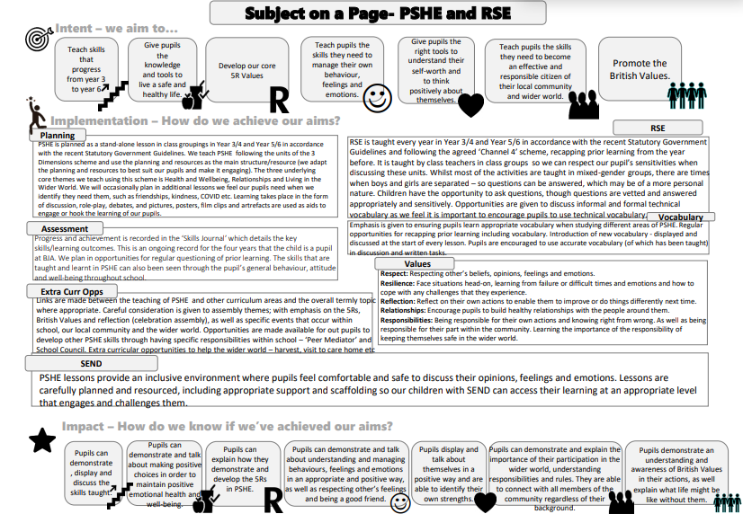

RE: Religious Education and Collective Worship

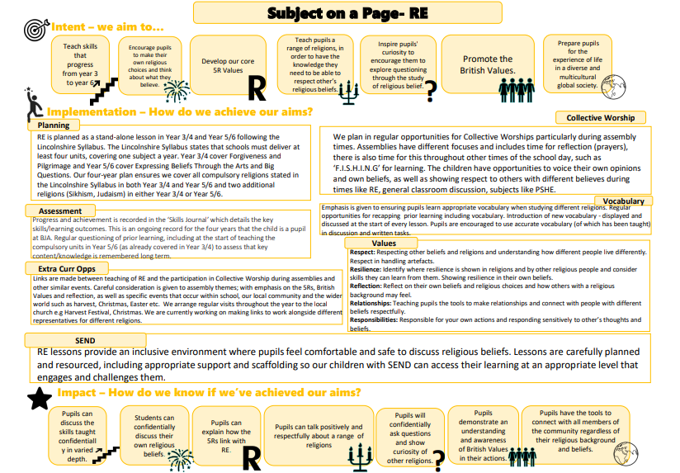

Multi-cultural Education

INTENT | IMPLEMENTATION | IMPACT
All aspects of life at our school, revolve around 5R’s – Respect, Resilience, Relationships, Reflection and Responsibility. These R’s are referred to in all aspects of the school, including assemblies.  At Branston Junior Academy, we believe that children benefit from learning about other cultures, as it enables us to celebrate the diverse cultures or our local, national and global society, and promotes positive attitudes towards ethnic differences and racial equality.  At Branston Junior Academy our focus on multi-cultural education ensures that:  - all pupils achieve their full potential  - all pupils are prepared for life in a diverse and multi-ethnic society  - all pupils understand what prejudice means, how discrimination occurs and how they can take a stand against all forms of discrimination and racism  - our Academy challenges and deals effectively with all racist and discriminatory incidents | Multi-cultural education is taught through many other curriculum areas, such as: English, Art, RE, PSHE, History and Geography. It is also incorporated in, or used as a basis for, the overall termly topics.  Multi-cultural education also features in assemblies and other similar events.  Children are encouraged to explore and develop ideas so that they can make informed judgements.  Staff endeavour to promote and enrich multi-cultural education by working in collaboration with staff and pupils from schools in other countries, such as Poland, Spain, Morocco and Guadeloupe.  Staff also ensure that displays and literature which portray people from every ethnic background and community in a positive way, are used wherever possible. Pictures, posters, filmclips and natural objects are used as a source for ideas and as a stimulus to aid the children’s learning.  The children are taught in mixed ability groups, to which all resources are easily and equally accessible. | Multi-cultural themes in assemblies, are recorded by the relevant Subject Leader, to ensure diversity in topics.  The relevant Subject Leader is also able to monitor termly planning to ensure that children are being exposed to a diversity of cultures.  As a result of studying Multi-Cultural Education, children are equipped with opportunities to:  - develop respect for, and knowledge of, the beliefs and of others  - develop knowledge and understanding in the similarities and differences between peoples, and that it is ok to have differences  - develop a greater sense of themselves as a global citizen and the part they can play both now and in the future, in making the world a better place to live for all peoples, no matter what their beliefs
PE: Physical Education
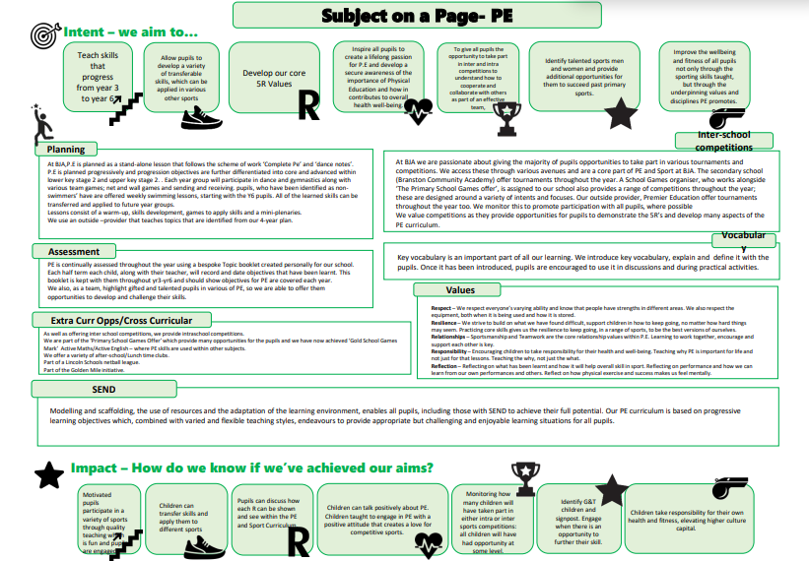

RSE: Relationships and Sex Education

INTENT | IMPLEMENTATION | IMPACT
Branston Junior Academy believes that children should be taught aspects of RSE as part of the Science lessons on ‘the human body’, but also that the teaching of RSE is vital in learning about the importance of healthy relationships.  We also believe that it is important for all relationships and family structures to be recognised, without any form of prejudice; thus, ensuring that our pupils develop a healthy respect for the feelings and beliefs of others.  Knowing that Lincolnshire continues to have one of the highest rates of teenage pregnancy in the country, we believe that it is important for children to be given age-appropriate facts about sex education; with an emphasis on the importance of the need for strong, loving relationships between partners, when teaching ‘Sex Education’ lessons.  Parents have the right to withdraw their child from sex education lessons if they so wish. Children who are withdrawn from the lessons will be given work to do under the supervision of another teacher. However, school recommends that parents do not withdraw their child from these sessions as we believe that it is better for children to hear facts from a member of staff, given within the correct context of a lesson, rather than children listening to ‘gossip’ in the playground.  Any reports of sexual harassment or sexual violence, be this physical or online; is taken seriously and dealt with in the same way as any other safeguarding disclosure. | Lessons are taught by members of the Academy staff following the agreed ‘Channel 4’ scheme. The Academy makes every effort to teach Sex Education in the context of social and emotional education. The Academy makes every effort to respect children's sensitivities when discussing Sex Education matters.  Whilst the vast majority of the activities are carried in in mixed-gender groups, there are times when the boys and girls are separated. This is usually so any questions can be answered, which may be of a more personal nature.  The staff use the following resources:  - Channel 4 All About Us:  - Living and Growing – Alternative DVD Y3/4 – Unit 1  - Alternative DVD Y5/6 Unit 1, Unit 2 and Unit 3  - PSHE 3 Dimensions Key Stage 2 Primary 4-7  Other resources may be used when teaching such as:  - Sex and Relationships Education by Molly Potter 7-9 (LKS2) and 9-11 (UKS2)  - Living and Growing Unit 1-3, Resource Book by John Lloyd and Clare Rowland  - My Amazing Journey by Pat Thomas  - How Did I begin? By Mick Manning and Brita Granstrom  - www.talktofrank.com  - Talk PANTS  - Your Mummy Ate My Football by Lynwen James  - Boys and Girls by Lynwen James  Children have the opportunity to discuss worries and concerns and ask any relevant questions to class teachers. Questions are vetted by teachers before the session with a predominant focus on puberty and what the children have already learnt in these sessions. Teachers answer the questions sensitively and the best they can and only discuss and answer questions that are relevant and appropriate. If teachers feel any questions are inappropriate, they will tell the child to discuss this with their parents/carers. If a child discloses something teachers will carry out and follow the appropriate safeguarding procedures.  Parents are consulted and informed about the lessons that their children will receive. They are given the opportunity to discuss with staff the content of lessons that deal with particularly sensitive information and ask any questions they have. They are given the opportunity to look at resources and watch any DVD programmes that might be used in sex education lessons.  Teachers adapt the teaching and planning by differentiating and personalising the learning, so it is accessible for all pupils including those with special educational needs and disabilities where necessary. The planning and delivery of content may be adapted where appropriate for individuals which may include discussions with parents. A child’s SEND should not be a consideration for the head teacher in deciding whether to grant a parental request to withdraw their child, however there may be exceptional circumstances when the head teacher will want to take a pupil’s SEND into account when making this decision.  In Year 3/4, children learn about:  - body statistics (weight, hair and eye colour for example)  - physical, emotional and mental health  - healthy lifestyles  - personal hygiene  - nutrition and food  - aspirations  - emotions  - growing and changing from infancy  - male/female body parts  - similarities and differences  - first aid (Every 2 years)  - relationships  - different types of families and people who care for me  - being safe  - online relationships and being safe online – e-safety (see e-safety policy)  In Year 5/6 children cover all of the above and:  - study the effect of the growing process on the body  - understand the importance of puberty  - study the physical differences between males and females  - learn about the reproduction cycle in humans  - learn about drugs, alcohol and tobacco  - understand that there are different types of relationships, including same sex relationships  In Y5/6, at the start of the topic, children have the opportunity to acknowledge and discuss both informal and formal technical vocabulary. Teachers discuss at length which words are inappropriate and which words are appropriate and therefore what words will be used throughout the sex education sessions. This is because we feel it is important to encourage the children to refer to the technical vocabulary. | As a result of studying RSE, children learn:  - how to keep themselves physically and mentally healthy  - knowledge about themselves and others and how puberty will affect them  - the importance of strong, healthy, respectful and loving relationships with others  - the human reproductive cycle  - that there are different types of relationships and family structures, and that this is ok
Drugs Education

INTENT | IMPLEMENTATION | IMPACT
At Branston Junior Academy we believe that all drugs have the potential for harm.  The Academy defines ‘drugs’ as:  - substances with addictive properties (as defined under the Drugs Act 1971)  - substances containing stimulants such as caffeine and ‘E’ numbers  - substances with medicinal properties (eg; penicillin, aspirin)  The Academy distinguishes between the substances identified in 1. and 2., which may be considered harmful and which require an educational program, and those identified in 3., which are considered necessary for medical reasons.  Branston Junior Academy wish to ensure the health and safety of all users of the Academy, by educating them about the effects on their body, of the substances defined in 1. and 2. | All children are taught about the effects of drugs on the human body, as part of their Science and their PSHE curriculum and about the moral issues relating to drugs - why some people choose to take them and the consequences of substance abuse etc.  In all teaching, children’s understanding of issues relating to drugs is sought and taken into account as part of the curriculum they are given.  In Year 3/4, children learn about the effects of tobacco and alcohol on the development of the body.  In Year 5/6, children revisit the above information and learn about the dangers to the body, of substance abuse.  The Academy may use the expertise and knowledge of outside agencies alongside the expertise of teachers wherever possible; to deliver those aspects of the curriculum that it has neither skills, experience nor equipment to provide. | As a result of studying Drugs Education, children learn:  - that some drugs are useful (medicines) and some drugs are not, but all have the potential to harm if used inappropriately  - that it is better to have a healthy lifestyle, without using non-medicinal drugs  - how to keep oneself safe

Management of drug-related incidents

The Academy defines the nature of a drugs related incident on Academy premises according to Section 3.5 of Drugs: Guidance for Schools (HMSO 2003), and the term ‘Academy premises’ as:

- the site of the Academy as defined by its perimeter fencing;

- any other location used by pupils as part of an activity formally organised by a member of the Academy staff

The response to any incident taking place on the Academy premises will cover the period when the Academy is actively in session (8.45am – 3.40pm, Monday to Friday). The response to any incident covered by 3.1.b will last during the length of the time of the activity.

The Academy includes the following as examples of a drugs related incident:
- pupils bring tobacco, or tobacco related products to the Academy
- pupils reporting the loss of medication in the Academy
- pupils finding an unknown medicinal-looking item in school

It will treat any incident involving a child and drugs (as defined in this policy) as having the potential to cause child abuse, and will follow procedures as set out in our ‘Child Protection and Safeguarding’ Policy; in order to ensure the safety and welfare of the child. The Academy will also take the following courses of action in respect of the incidents listed below:

- Drugs and associated paraphernalia found on Academy premises:
- a member of staff will take temporary possession and place equipment securely under the supervision of a member of Academy staff and stored away from children’s medicines to prevent any harm to an individual.
- the above act will be witnessed and details recorded. Police will be informed if Class A, B or C drugs are involved
- pupils will be asked for permission to search their belongings.

- A pupil found in possession:
- isolate the child in a secure supervised place
- notify parents immediately
- notify the police immediately
- record all details

- A pupil actively supplying:
- isolate the child in a secure supervised place
- notify parents immediately
- notify the police immediately
- record all details

- A pupil under the influence:
- isolate the child in a secure supervised place
- notify parents immediately
- notify the police immediately
- record all details

- A pupil discloses knowledge of the local sale of drugs:
- notify parents immediately
- notify the police immediately
- record all details

- A pupil discloses drug abuse in the family
The procedure to follow is set out in the ‘Child Protection and Safeguarding’ Policy – with particular reference to the section on ‘Disclosure’. At all times there is a need to ensure the welfare and safety of the child and the parental right to be informed.

- A parent/carer/staff member under influence:
- approach individual and attempt to persuade them to remain calm until effects wear off
- contact police if their behaviour is inappropriate/threatening.
- if it is a staff member; suspend with immediate effect, place in isolation until in a fit state, then send home. Inform Chair of Governors and convene Disciplinary Panel.

- Pupils bringing tobacco/related products into school:
- confiscate materials, search pupil’s bags/trays
- notify parents

- Pupils reporting loss of medication:
- question child over movements
- contact parents to establish details
- search area to try and find
- warn all pupils/adults on the premises

Access to alcohol by children during Academy organised activities (eg; for the Christmas Fair) will be controlled by ensuring that such products are clearly labelled and that children will not be allowed any contact with them.

Please also see the Branston Junior Academy ‘Substance Misuse Policy’
Information for Parents:
Relationship and Sex Education – What do we teach at Branston Junior Academy?
In Y3/4 children will be taught:
- Naming male and female body parts (including sex parts)- link to Science
- Identifying the similarities and differences between males and females- link to Science
- Understanding the life cycle from foetus to old age- link to Science
- To understand that a sperm and an egg is needed to make a cell- link to Science
- To understand personal hygiene and why it is important as we begin to go through puberty
- Understand that as we grow we become more independent
- Key facts about puberty and the changing adolescent body, particularly from age 9 through to age 11, including physical and emotional changes- sweat more, body shape changes- getting taller, spots, hair will grow, greasy hair
- Understand the difference between appropriate and inappropriate touch
- Understand that the make-up of family units can differ
In Y5/6 children will be taught all of the above and:
- Name all male and female sex parts- address that some vocabulary is not appropriate
- Understand how puberty differs for males and females
- Understand that sex between and man and women may result in pregnancy and that this is caused when the sperm enters the egg
- Review and extend on prior key facts learnt about puberty and the changing adolescent body, particularly from age 9 through to age 11, including physical and emotional changes. Menstruation, body changes- breasts growing/ body shape changing, discharge, hair growing, mood changes, wet dreams, erections may begin, voice breaks, muscles develop etc.
- To understand about menstrual wellbeing including the key facts about the menstrual cycle. Explore products available.
- Understand the concept of respecting body autonomy
- Know about gender identities and have an awareness of transgender issues, including gender reassignment
- Understand the terms associated with different sexualities and understand that this is a protected characteristic
- Identify the difference between healthy and unhealthy relationships
It is important to be aware that at the start of the topic Year 5 and 6 do acknowledge and discuss both informal and formal vocabulary, which may include slang words. This is an open discussion and so staff have minimal control over words used - but staff do discuss at length which words are inappropriate and which words are appropriate and therefore what words we will be using throughout the sex education sessions. This is because we feel it is important to encourage the children to refer to the technical vocabulary.
As well as discussing vocabulary, we give the children the opportunity for a question and answer session. This is where children have the chance to write down questions about what we have already covered/discussed. Questions are vetted before the session with a predominant focus on puberty, we try to answer these questions sensitively and the best we can and only answer the questions we feel are relevant and appropriate.
Although Sex Education is not compulsory in primary schools, in response to the fact that Lincolnshire has one of the highest pregnancy rates we feel it is important to touch on sex education such as how a baby is created, loving/committed relationships and the birth of a child.

Resources
- Channel 4 All About Us: Living and Growing – Alternative DVD Y3/4 – Unit 1 Y5/6 Unit 2 and Unit 3
- PSHE 3 Dimensions Key Stage 2 Primary

Other resources may be used when teaching such as:
- Sex and relationships Education by Molly Potter 7-9 (LKS2) and 9-11 (UKS2)
- Living and Growing unit 1-3 resource book by John Lloyd and Clare Rowland
- My Amazing Journey by Pat Thomas
- How Did I begin? By Mick Manning and Brita Granstrom
- www.talktofrank.com
- Talk PANTS
- Your Mummy Ate My Football by Lynwen James
- Boys and Girls by Lynwen James

The right to withdraw your child
Parents have the right to withdraw their child from sex education lessons if they so wish. Children who are withdrawn from the lessons will be given work to do under the supervision of another teacher. However, it is encouraged that your child takes part in this learning as we feel it is beneficial for your child to hear accurate information from a teacher (as opposed to playground gossip from a friend), which is also part of the school curriculum.
We do offer the opportunity for parents to come into school to ask any questions and view materials we use prior to these sessions. A letter will be sent out to parents beforehand if you wish to attend this.

