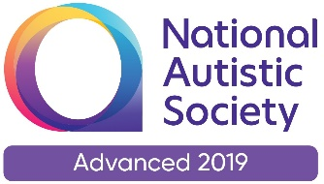cid:image015.jpg@01D581E6.D1B3F270

This is for ***parents/carers*** of children (with social communication differences or social vulnerability) in ***Years 5 and 6***

This will be an information session led by **The Working Together Team** exploring how to seek the ‘right’ secondary school for your child & navigate the process. All schools are different and some will ‘suit’ your child better than others.

We will explore *what to look for, possible questions to ask, who to speak to, when to visit* etc.

**Date: 2nd November 2021 via Teams**.

If you’d like to book a place please use the Eventbrite link below. A joining link will be shared with you the day before the event

[**https://www.eventbrite.co.uk/e/parent-workshop-prepare-not-scare-tickets-170413495352**](https://www.eventbrite.co.uk/e/parent-workshop-prepare-not-scare-tickets-170413495352)

You will have the option to turn your cameras off/on, please can microphones be muted to limit background noise. Thank you.

**Time: 9.30am – 11:30 am** *approx.*

Any questions please feel free to contact us and we look forward to ‘seeing’ you there!

Adele Sheriff Louise Wilbraham

[adele.sheriff@twtt.org.uk](mailto:adele.sheriff@twtt.org.uk) [louise.wilbraham@twtt.org.uk](mailto:louise.wilbraham@twtt.org.uk)

**The Working Together Team Invites You to**

**A FREE *Online Workshop***

**‘Prepare not Scare!’**