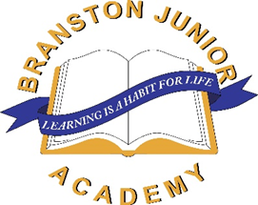

Branston Bulletin
02.05.25

Our Week

Well, what a busy week and warm week we have had! The children have really got stuck into our theme of Extreme Earth in their learning this week. It feels appropriate what with the high temperatures we have been enjoying!


Learning

In our learning the children have been learning about the layers of the Earth. As I have been around school the children have been making models showing the different layers of the earth and in one classroom there was even a replica volcano exploding! The children have had a fun time beginning to learn about the planet they live on.

Y3/4 have also been learning about Money this week in Maths and with many of us using digital forms of currency it is a valuable home task to count and be familiar with coins. So if you do have some coins the children can count and make totals and find change this would benefit their current learning.

Y6 SATs


On 12th May our Y6 children will sit their end of KS2 assessments. Inknow the children have been working really hard and they are determined to show off all the new learning they have acquired across KS2. Whilst the assessments will only form part of the days from Monday to Thursday it is very helpful to the children if they get a good nights sleep each evening and breakfast in the morning. I’m proud of how the children are approaching this week and our value of resilience has been very much in evidence recently.

Our Pupil Voice

What have been the highlights for our children this week?

Eden Y3 – ‘I enjoyed doing Maths and my subtraction’
Finn Y3 – ‘I enjoyed football this week’
Rosie Y6 – ‘I really enjoyed making the models showing the layers of the Earth.’
Jack Y6 – ‘I really liked learning about shapes in Maths’

Looks like Maths was popular this week. Good to see so many budding mathematicians in school.

Swimming Y3/4

Y3/4 children attended a swimming gala at Branston Community Academy on Monday. We were proud of how they performed using a range of strokes and for many this was their first gala. Our children competed very well and even got on the podium in some of the races. Well done!

Weather

As mentioned earlier we have had a fabulously sunny week. We don’t know if this will last but whenever the weather gets warmer could remind families that children should attend school with sun cream that they can apply themselves and a hat. Water can be brought in water bottles, but water is also readily available in school.

Bank Holiday

This week the children have worked so hard I’ve decided to give them a day off on Monday!! Joking aside please remember that next week we start back on Tuesday 6th May.

Mr Thornton’s Book Corner

This book challenges children to think about what the future might look like in a gripping way!
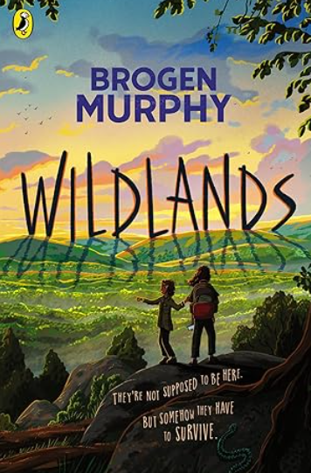
Twenty-five years into the future, no humans are allowed in the Wildlands – a vast area in Britain where wolves, lynx and bison roam free. The only exception is a high-speed train line between London and Glasgow that crosses right through the heart of the project. Thirteen-year-old Astrid and her little sister, Indie, are onboard when their train slows to a brief, unexpected stop … and they find themselves accidentally left behind. Stranded in this place of astonishing natural wonders and terrible dangers, they have only a rucksack, a phone without signal – and each other. As every wrong turn takes them deeper into the Wildlands, do they have the ingenuity and determination to survive?

Mr Thornton

Headteacher


Diary dates 2024-2025:

- Bank Holiday – Monday 5th May
- SATs Week – w/c 12th May
- Year 6 Bikeability – Monday 19th – Thursday 22nd May
- Year 2’s at BJA for the day – Thursday 22nd May
- Summer Term 1 ends – Friday 23rd May
- Summer Term 2 starts – Tuesday 3rd June

Please do look on our website and scroll down to the ‘Forthcoming Dates’ section Diary - BranstonJunior (branstonjunioracademy.co.uk) to find dates of all events.

Useful information on our website
Please go to our website: www.branstonjunioracademy.co.uk where you will find lots of useful information.

Under the ‘Parents’ tab, you will find information about:
- Information and events to support families.
- Mobile phones
- Second hand uniform
- Holiday / Medical Appointments
- Useful ‘Letters and Forms’
- Your School Lottery

Under the ‘Curriculum’ tab, you will find lots of useful information about how to help your child with their learning.

This page: https://www.branstonjunioracademy.co.uk/local%20events.asp has information on a whole range of local events.

Mr Pyburn’s E-Safety ‘top tip’
Roblox updates their parent toolkit
Roblox have recently made the news with their announcement of improved safety for children through an improved set of tools for parents to manage. Internetmatters.org have created an easy-to-follow guide and overview for parents to see.

This guide also includes links to the Roblox press announcement and a link to a step-by-step guide on how to setup parental controls within Roblox.

The internetmatters.org link also contains useful information about Google's updates to Google Family Link and, useful if you have children of secondary school age, information about updates that TikTok have made to help teens (TikTok is for 13+ years in the UK) have a safer TikTok experience through the Family Pairing tool. All can be found at:
https://tinyurl.com/wswtynma



