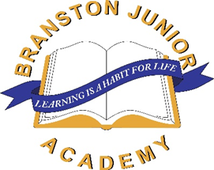

Branston Bulletin
09.05.25

Dear Families,

It has been a busy week in school. As I have moved about the school children have been working intently on their new learning. Whether this be learning about geographical features of our ‘Extreme Earth’ or whether this has been using our investigation skills in science. Children are progressing well and giving teachers much food for thought when they comment upon children’s progress in end of year reports.

VE Day

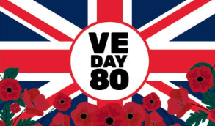
Across the nation we have been paying tribute to those who have given their lives for their country. The children have been learning about VE day through a special assembly on Thursday where we looked at the impact of the war on children, families and service personnel. We looked at how VE was being celebrated both locally in Branston and nationally. Some of our children have been working hard across the past few weeks to develop art work which will form part of the VE celebrations at Branston Village Hall on Saturday 10th May between 12pm-6pm. If you do have some spare time then do go along and see some of the wonderful art work that the children have produced. There will also be vehicles and military vehicles from 1940s on display.

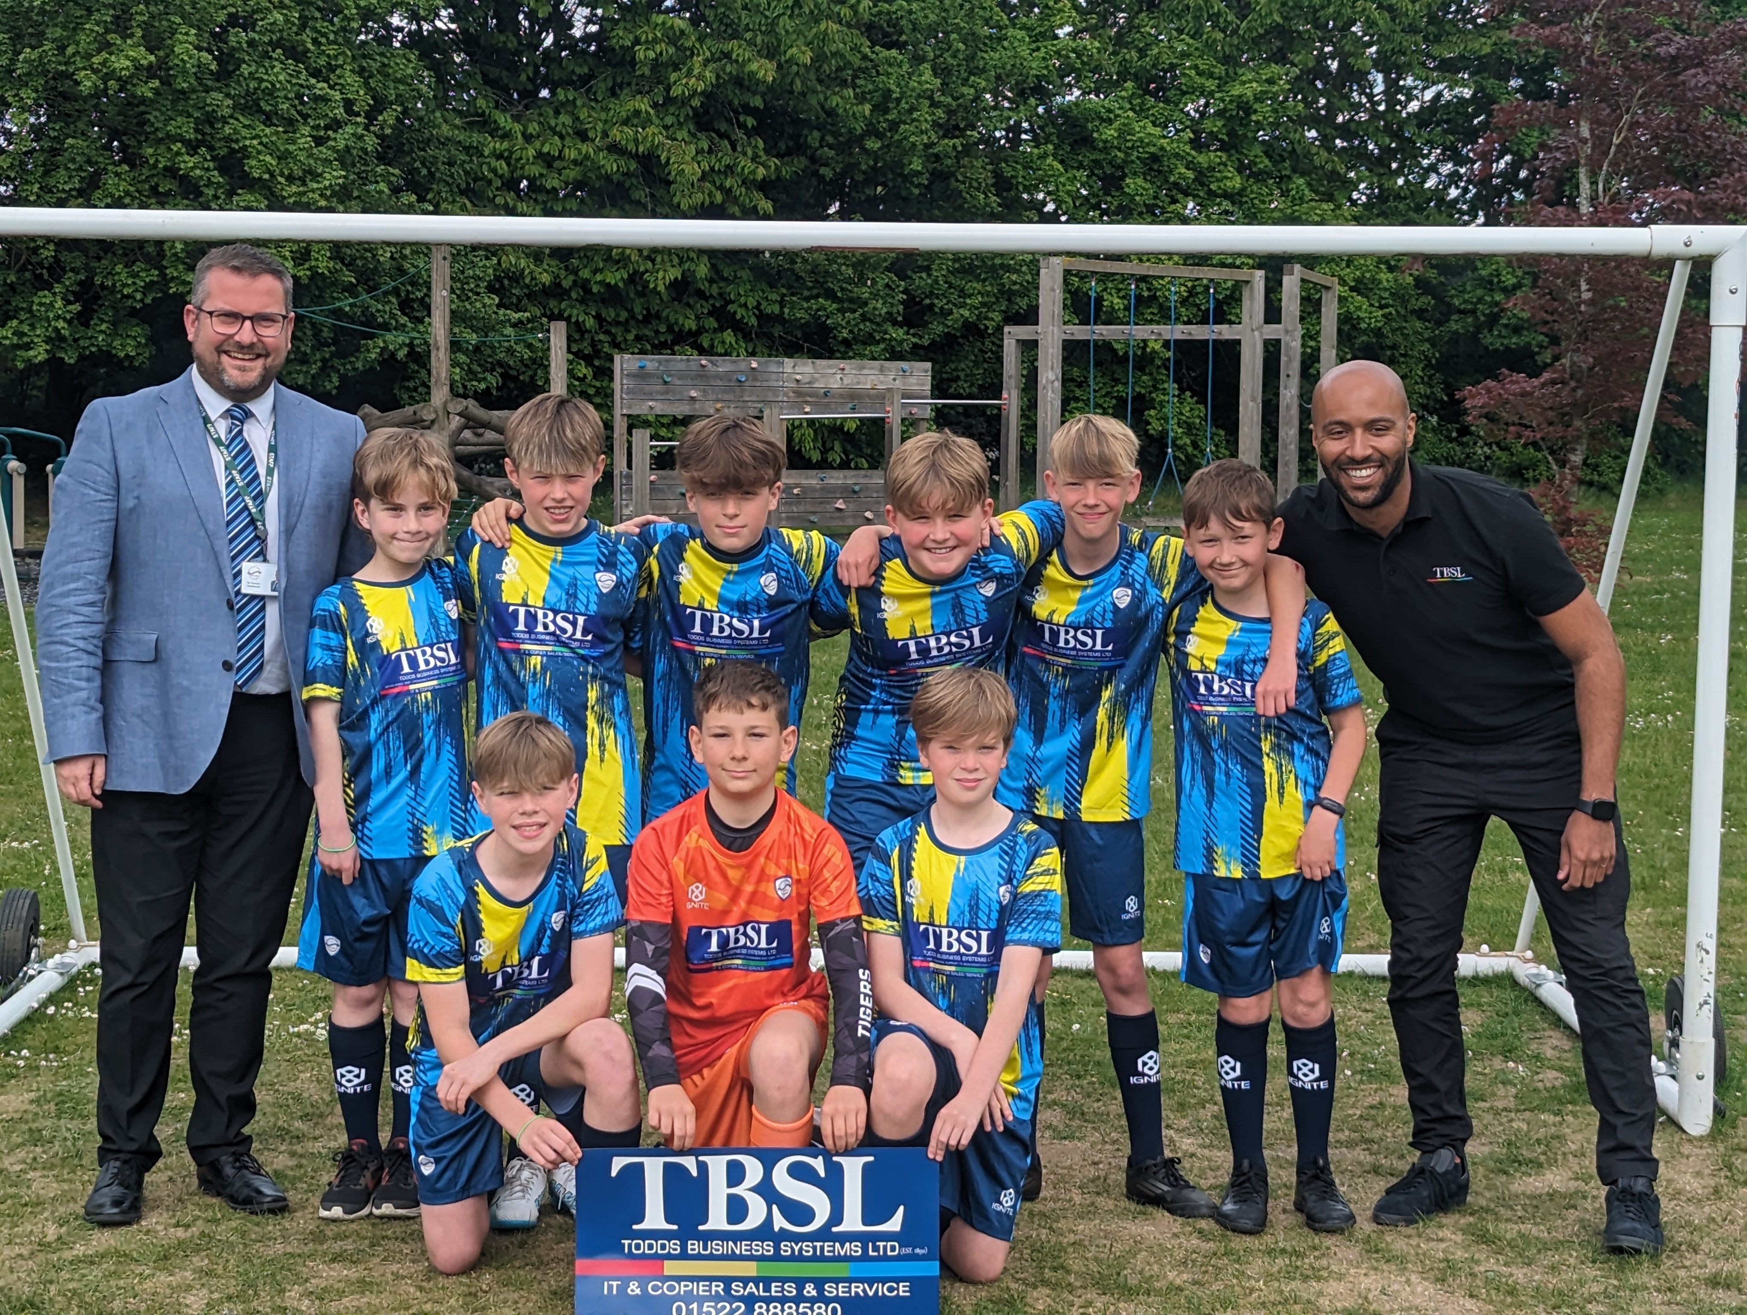
Football Kit

This week we were very excited to take ownership of the school’s brand new football kit. We are thrilled that our sponsors TDSL have enabled this to happen and special thanks must go to Miss Robinson for all her hard work in designing and ordering the new kit. I am sure you’ll agree it looks very modern and smart and everywhere we go we can represent Branston Junior Academy with pride.

Our Pupil Voice

What have been the highlights for our children this week?

Georgia Y3 – ‘I have really enjoyed that thing beginning with ‘P’ in Maths. Oh yes perimeter!
Ava Y3 – ‘I enjoyed Art this week, we learning how to make a collage.’
Charlie Y5 – ‘I really enjoyed Computing this week where we found out about lots of different search engines and we were taught how to use these safely.’
Ryley Y5 – ‘We made collages linked to Extreme Earth. We made biomes with collage. It was fun to do.’

It is important that we prepare our children for the world in which they will live in so its good to see children enjoying being taught online safety.

Science

One of the areas the children have really enjoyed this week is Science. Across the school children have been learning about the Science behind extreme Eart. Y5/6 have been using Newton meters to measure gravitational pull. This was very interactive and enjoyed by all the children.

Y6 SATs

Across next week our Y6 children will demonstrate what they have been learning across KS2. I’m sure you will join me in wishing them all the best. The children have been a credit to you, our school and most importantly a credit to themselves. Remember Y6 a good night sleep will help you as you go through the week.

Mr Thornton’s Book Corner
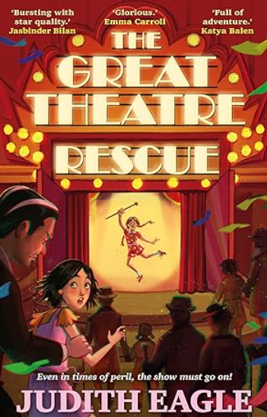
1930, London Theatre Land. Charley has grown up behind the curtain in London's West End; she has even begun taking a turn on stage.
But her dreams of being a performer are shattered when she is sent off to boarding school, a place where the girls are forced to do unpaid work in order to fill the pockets of the owners. When she discovers that her theatre home is in peril, Charley decides to escape, and make a dangerous journey along the coast in order to get back to - and save - all that she loves.

Mr Thornton

Headteacher


Diary dates 2024-2025:

- SATs Week – w/c 12th May
- Year 6 Bikeability – Monday 19th – Thursday 22nd May
- Year 2’s at BJA for the day – Thursday 22nd May
- Summer Term 1 ends – Friday 23rd May
- Summer Term 2 starts – Tuesday 3rd June

Please do look on our website and scroll down to the ‘Forthcoming Dates’ section Diary - BranstonJunior (branstonjunioracademy.co.uk) to find dates of all events.

Useful information on our website
Please go to our website: www.branstonjunioracademy.co.uk where you will find lots of useful information.

Under the ‘Parents’ tab, you will find information about:
- Information and events to support families.
- Mobile phones
- Second hand uniform
- Holiday / Medical Appointments
- Useful ‘Letters and Forms’
- Your School Lottery

Under the ‘Curriculum’ tab, you will find lots of useful information about how to help your child with their learning.

This page: https://www.branstonjunioracademy.co.uk/local%20events.asp has information on a whole range of local events.

Mr Pyburn’s E-Safety ‘top tip’
The NSPCC Phone safety toolkit
If your child is about to get their first smart phone or a new connected device, then it’s a great idea to plan ahead for how they will use it safely. The NSPCC have created this toolkit to make it easier for your family to feel confident about starting this journey together. This may well be especially pertinent for parents of Year 6 children who are thinking of purchasing their child's first smart phone in the lead-up to transition to Year 7. The NSPCC resources can be found at:
https://tinyurl.com/3pxx9wwc



