

Branston Bulletin
25.04.25


Welcome back to the Summer Term!

It’s hard to believe the summer term is upon us. We are all set for a busy and exciting term here at Branston Junior Academy. Your children have lots of interesting and fun learning to take part in, coupled with some exciting school events! Look out for more information coming soon!


Learning

This term your children are starting a new topic, Extreme Earth. This topic will support your children to learn more about volcanoes and earthquakes and develop their geographical knowledge. The children will also be using our ‘Extreme Earth’ to develop their learning in English and Science.

Website

Over the Easter holiday we have been busy building our new school website. Our new school website will be a place to find key information quickly, find links to those all important pages, such as term dates, and will also be more mobile friendly. The new website will shine a light on all the fantastic learning and opportunities BJA has to offer and this is the start of building a modern school for our children’s futures here in Branston.

Clubs

We know how many of the children love the clubs that we run for the children. These will start again from Monday 28th April. Please check the finish times of the clubs so that you are able to collect your children promptly.

Mr Thornton’s Book Corner

Here is a school based Fatansy novel named ‘School of Doom.’ A fantastical talw which is fantastical but has a strong theme of morals running through it.

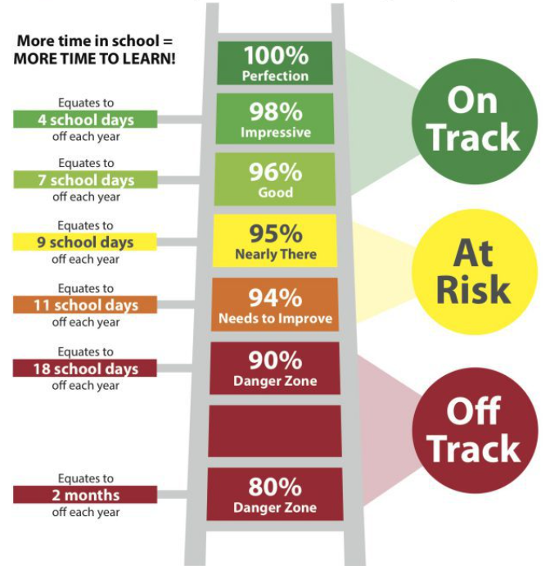
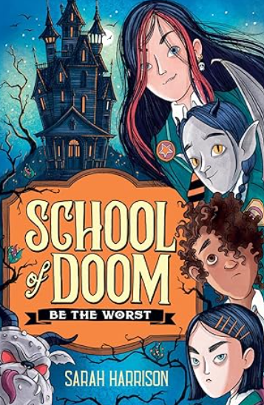
Eddie can eat a wheelie bin as easily as a cheeseburger – a talent that gets her sent to the School of Doom with its motto, Be the Worst.
Now Eddie may be beastly. But she's not evil.
When her new friends are plunged into danger, can she be the best of the worst and save them?

Attendance

We know that school attendance is important for children’s social and learning development. Here is a reminder of the impact of attendance on learning and where our classes are currently placed. You can see that whilst many pupils have fantastic attendance at school we do need to continue to strive for the best attendance possible. We appreciate your help with this by sending your children to school even if they are ‘under the weather’ and not taking term time holidays. We do understand that some absence from illness cannot be helped.
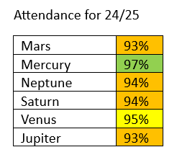
Thank you for your continued support and do not hesitate to make contact with me if there is anything you wish to discuss further.

Mr Thornton

Headteacher


Diary dates 2024-2025:

- Bank Holiday – Monday 5th May
- SATs Week – w/c 12th May
- Year 6 Bikeability – Monday 19th – Thursday 22nd May

Please do look on our website and scroll down to the ‘Forthcoming Dates’ section Diary - BranstonJunior (branstonjunioracademy.co.uk) to find dates of all events.

Useful information on our website
Please go to our website: www.branstonjunioracademy.co.uk where you will find lots of useful information.

Under the ‘Parents’ tab, you will find information about:
- Information and events to support families.
- Mobile phones
- Second hand uniform
- Holiday / Medical Appointments
- Useful ‘Letters and Forms’
- Your School Lottery

Under the ‘Curriculum’ tab, you will find lots of useful information about how to help your child with their learning.

This page: https://www.branstonjunioracademy.co.uk/local%20events.asp has information on a whole range of local events.
Mr Pyburn’s E-Safety ‘top tip’
Free Online Safety Q&A events for parents & carers - hosted by the Stay Safe Partnership
The Stay Safe Partnership deliver Online Safety workshops in Primary and Secondary schools across Lincolnshire everyday. They are hosting two online (via Teams) events in May that aim to provide parents and carers the most up-to-date information and tools about what your children are experiencing online, so you can feel confident in keeping them safe from online harm whilst still allowing them to explore the online world. Whether you want to know more about age appropriate apps, online trends, parental controls, social media or any other burning questions this is the event for you! Sign up is required.
Stay Safe Partnerships Online Safety Q+A for Parents of Primary Aged Children 14th May 2024 6-7:30pm FREE TEAMS event sign up required: https://tinyurl.com/ye23kfkt

Stay Safe Partnerships Online Safety Q+A for Parents of Secondary Aged Children 7th May 2024 6-7:30 pm FREE TEAMS event sign up required: https://tinyurl.com/2mf8rx63


