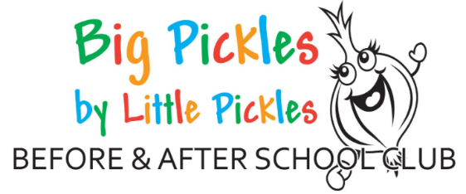

Welcome to Big Pickles Before and After School Club

Big Pickles Before and After School Club are committed to providing the best care for all children. We have two sites which run at Branston Infants School and Branston Junior Academy. We are a committee led organisation, which is made up of trustees who are a group of volunteers, some of whom are parents, past and present. Without our trustees our Before and After school club could not open.

Introduction to Big Pickles
We would like to welcome you and your child to Big Pickles Before and Afterschool Club. We are open for children who are in reception class to year 6.
We operate from 7:45 AM until the start of school in the morning. In the afternoon, we open from the end of school until 6:00PM - Monday to Friday.

Fees
The following fees apply to Big Pickles Before and After school club.
Session | Fees | Additional Information
Before School Session | £6.00 | Includes Breakfast: Must arrive before 8:15am
After School Session 4:30pm collection | £5.50 | Includes Snack
After School Session 6:00pm | £11.00 | Includes Snack on arrival plus additional fruit as required
Late Charge | £5.00 | Per 15 minutes after collection due time

All bookings are made via an online booking system. To register your interest with us, please complete the enquiry form: https://app.famly.co/#/customInquiryForm/2b6339d8-9dfe-473f-92eb-063c29330012/to/05684df4-7671-4a9d-a7a7-7a5da0858183/submit

If fees are not received following an email reminder, then unfortunately your child will not be allowed to attend their session as normal until fees are paid in full. You will be notified that your child will not have a place at their normal session.
Parents who have booked and paid for sessions but decide to collect their child(ren) directly from school or early from after school club will not receive a refund as a place will have already been allocated.

Breakfast and Snack at Big Pickles
At Big Pickles we follow a healthy eating policy and use the School Food Agency guidance when planning our menus. Breakfast will be offered to children attending our morning session, a range of breakfast foods such as Cereals, Toast, Fruit and Yogurt are offered. Children must arrive by 8:15am to have breakfast in order that they have enough time to eat it and for breakfast to be cleared away.
Afternoon Snack consists of a variety of healthy and light foods which will help tide your child over until they arrive home for their family meal. Fruit will be available throughout the session in addition to our main snack.
Drinks are supplied throughout all our sessions and include water or milk only.
We ensure that all dietary requirements are met, we just ask you inform a member of staff before your child starts. You are welcome to send in specialist snacks if your child has an allergy or intolerance or you are tracking what they eat for medical purposes. Please inform a staff member in such cases.

Activities
At Big Pickles we offer a wide range of resources and activities for children to take part in and follow children’s interests closely. We can use the outdoor areas within the school grounds and on the days where the weather is bad, we are able to use the school’s halls.

Holiday Club
We are also pleased to be able to offer a holiday club throughout the year outside of term time. This is run by Louise Exton-Brown. For further information please register your interest at: https://app.famly.co/#/customInquiryForm/2b6339d8-9dfe-473f-92eb-063c29330012/to/05684df4-7671-4a9d-a7a7-7a5da0858183/submit

How to contact us
There are many ways you can contact us at Big Pickles.
Email : big-pickles@little-pickles.com
Mobile phone: 07730 871244 (Junior Site) or 07732 337023 (Infant Site)
For anything urgent please phone: 01522 793112 – Please leave a message with the preschool if it is out of session times. They will ensure we receive your message.
Instagram: https://www.instagram.com/big.pickles.official

