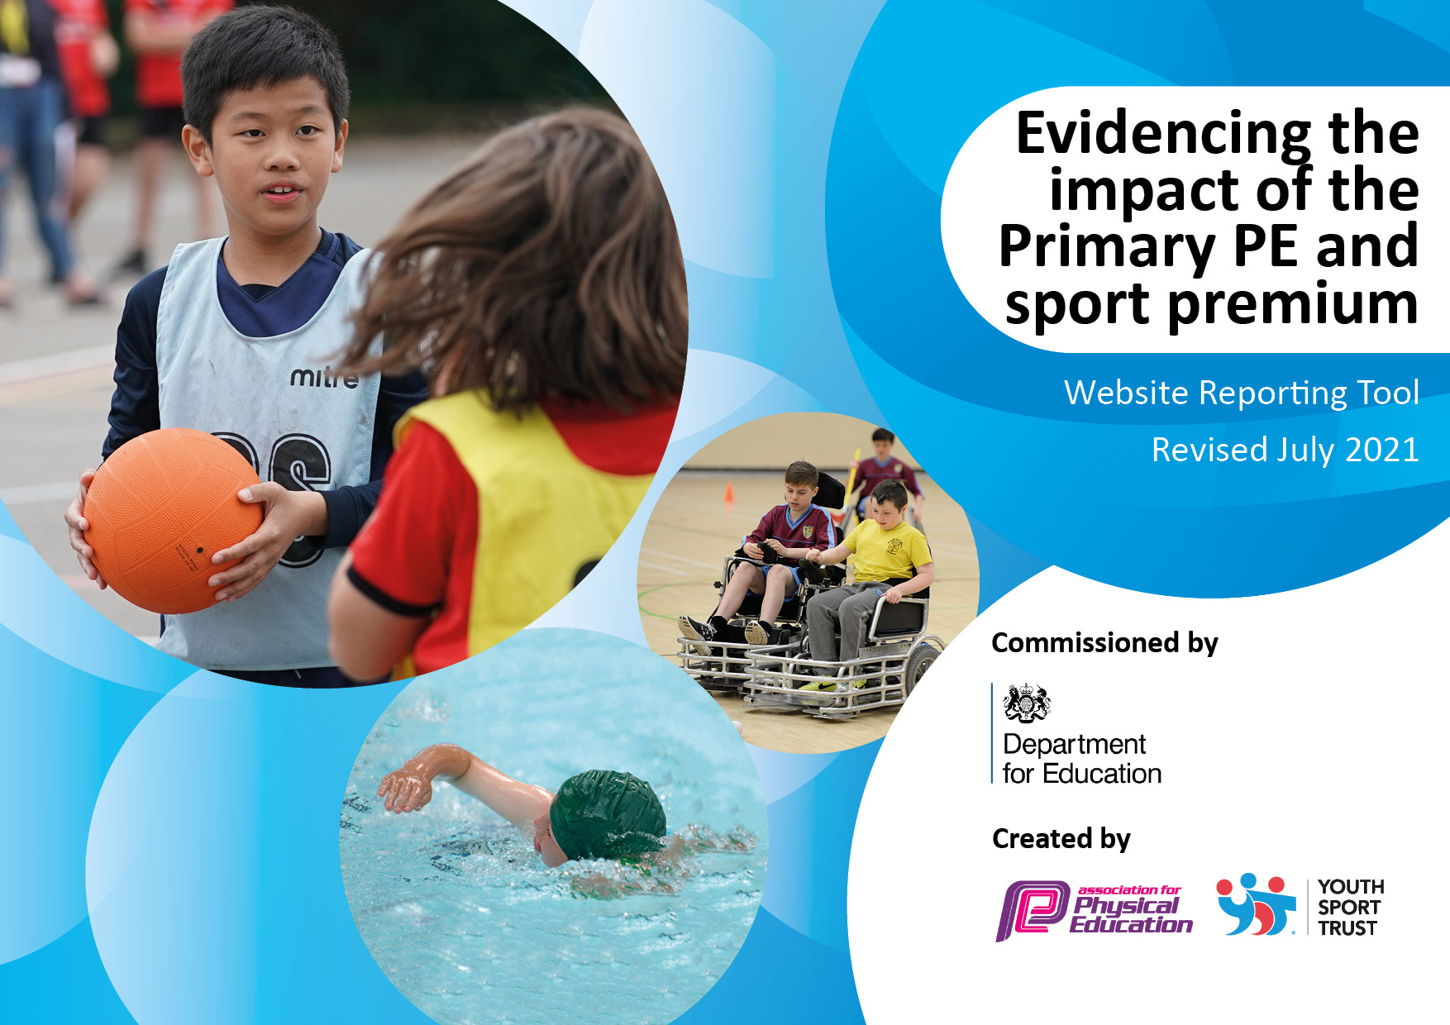
Details with regard to funding
Please complete the table below.
Swimming Data
Please report on your Swimming Data below.
Total amount allocated for 24/25 | £17,700
Total Spent: | £17,707
Swimming Data
Please report on your Swimming Data below.
Meeting national curriculum requirements for swimming and water safety.

N.B. Complete this section to your best ability. For example you might have practised safe self-rescue techniques on dry land which you can then transfer to the pool when school swimming restarts.
Due to exceptional circumstances priority should be given to ensuring that pupils can perform safe self rescue even if they do not fully meet the first two requirements of the NC programme of study
What percentage of your current Year 6 cohort swim competently, confidently and proficiently over a distance of at least 25 metres?
N.B. Even though your pupils may swim in another year please report on their attainment on leaving primary school at the end of the summer term 2020.
Please see note above
What percentage of your current Year 6 cohort use a range of strokes effectively [for example, front crawl, backstroke and breaststroke]?
Please see note above
What percentage of your current Year 6 cohort perform safe self-rescue in different water-based situations?
Schools can choose to use the Primary PE and sport premium to provide additional provision for swimming but this must be for activity over and above the national curriculum requirements. Have you used it in this way? | Yes/No

Action Plan and Budget Tracking
Capture your intended annual spend against the 5 key indicators. Clarify the success criteria and evidence of impact that you intend to measure to evaluate for pupils today and for the future.

Academic Year: 24/25 | Total fund allocated: | Date Updated:
Key indicator 1: The engagement of all pupils in regular physical activity – |  |  |  | Percentage of total allocation:
 |  |  |  | 31.4%
Intent | Implementation |  | Impact
Your school focus should be clear what you want the pupils to know and be able to do and about  what they need to learn and to  consolidate through practice: | Make sure your actions to achieve are linked to your intentions: | Funding allocated: | Evidence of impact: what do pupils now know and what can they now do? What has changed?: | Sustainability and suggested next steps:
To offer a wide range of free after school sports clubs that therefore offer extra engagement in physical activity – therefore falling into the recommended 30 minutes activity per day. | Use Premier Education to offer a variety of after school sports clubs.  Use Jim Gillespie to implement highly-skilled sports clubs inc: football and athletics.  Boxercise annual license for LP | £4290  £1242  £33.33 | Gives all children the opportunity to try out a variety of sport over the academic year – without expense.  Gives the opportunity for children to take part in sessions with a professional athlete as their coach.  This did support children trialling extra-curricular sessions out of school which supports their regular physical activity. | Keep providing a variety of extra-curricular clubs that are open to all.  Pupil-voice – what clubs would children like to see within school.  Sign post children.
Key indicator 2: The profile of PESSPA being raised across the school as a tool for whole school improvement |  |  |  | Percentage of total allocation:
 |  |  |  | 3.8%
Intent | Implementation |  | Impact
The Premier Education Play Maker Award – it is designed to introduce young leaders to essential leadership skills through practical learning. Participants will engage in leadership activities that build resilience and can be applied in various settings, such as class sessions or extra-curricular activities.  All children to reach expected swimming level by the end of Y6 | Choose the 8 playleaders to give them confidence in their job supporting other children in play and sports. Having this skill will help support younger children with play and sports on the playground.  Y5/6 children assessed and offered swimming lessons throughout year – staff needed to support this. | £325  £355.18 | Moved forward into the next academic year.  Support children who do not get the opportunity to take part in swimming lessons outside of school. | Make sure this training is undertaken and look into other options for play awards for children to help children to support children for school relationships.

Key indicator 3: Increased confidence, knowledge and skills of all staff in teaching PE and sport |  |  |  | Percentage of total allocation:
 |  |  |  | 23.3%
Intent | Implementation |  | Impact
We feel that it is important to use some of the premium for P.E CPD Regular CPD is essential for engaging PE sessions as it equips educators with the knowledge and skills needed to inspire effective teaching. It helps teachers stay updated with the latest educational trends and teaching methodologies.  Buying into a dance scheme which will help Structured Learning: Dance schemes provide a structured approach to teaching dance, ensuring that all necessary components are covered, such as movement skills, rhythm, and creativity.  Updating P.E equipment to support confident and skilled teaching.  Making sure teaching areas and of a good standard. | To give P.E lead (teaches all yr5/6 P.E) CPD in areas they feel less confident. Gymnastics and football have been chosen.  Buy another addition to our ‘Madmusik’ dance scheme that will match the whole school theme for a term – hopefully support confidence in teaching dance.  Stock take equipment from the P.E shed at the start of the year - order new equipment that will support the teaching of all sports across the curriculum throughout the year.  Inspection and P.E equipment and painting of netball lines. | £1980  £71.99  £1541.77  £545 | P.E lead feels more confident in the areas that she had less knowledge on. It has helped shape how these lessons will be delivered in the future- this will help sustainability of skilled P.E teacher.  Teacher Confidence: Resources offer preprepared lesson plans and CPD, which can boost teacher confidence and alleviate nervousness when teaching dance  Confidence in ability to teach safely. | Book in more CPD for P.E leads second in command – yr3/4 teacher chosen so then there is a shared skill set across the school. To lock in areas, they feel they need CPD in.  Buying into a physical scheme and into new equipment helps the sustainability of confident and skilled teaching as you have to have the resources to support this. Stock-take and equipment check bi-yearly.
Key indicator 4: Broader experience of a range of sports and activities offered to all pupils |  |  |  | Percentage of total allocation:
 |  |  |  | 8.5%
Intent | Implementation |  | Impact
We pride ourselves of making sure there is one week in the academic calendar where the children get to be part of a broad experience of sports that they make have never had experience of.  Give opportunities to be coached on a different sport.  Have broad set of equipment for variety of sport. | Find experts and skilled teachers to deliver sports that children have not come across before. Glow in the dark dodgeball/archery and NERF war were included within these sessions for the children.  Specific year group (UKS2) to take part in training with a coach that will lead to a fixture day with other schools.  Purchase equipment for activity week. | £800  £475  £247.69 | All children had the opportunity to take part in these sessions and there was great enjoyment over the course of the sessions. Broadening children’s experience of different sport they may not try before.  Focus within later part of the school year – made a big improvement of other areas of curriculum (Also relates to Key Indicator 2) | Buy-in to equipment to use year on year for our annual activity week.  Plan more activities that can act as CPD for adults to look into including within the school calendar/curriculum.  Be able to have a wide range of equipment in my stock.

Key indicator 5: Increased participation in competitive sport |  |  |  | Percentage of total allocation:
 |  |  |  | 31%
Intent | Implementation |  | Impact
For all children to have the opportunity to take part in an inter-school competition.  Opportunities for the higher ability children to take part in school leagues. | Find sports and competitions that are inclusive and available for all.  Make sure there are staff available to be able to attend and cover classes to make these competitions achievable.  Spend money on travel, which is vital to attend competitions.  Enter both the Football and Netball Lincoln school leagues – giving ability to children to take part in higher levelled competition. | £810  £2940.29  £1700  £50 | All children were given the opportunity to take part in an inter-school competition which gave the children a sense of community and team within the school and year groups. This also raised the profile of competition and scaffolded children to join extra-curricular clubs.  This also had a positive impact on effort and participation in intra-school competitions.  Taking part in specific leagues also support those higher-skilled children to raise profile of school sports and made relationships with other schools. | Create relationships with variety of schools to continue inter-school competitions when there is less funding.  Keep entering these leagues and create opportunities for the higher ability children to have these opportunities.

